**PRACTICAL: 1**

**IMPLEMENTING CLUSTER ON WINDOWS**

**Steps:**

1) Install the **VMWare Workstation**. The **Home page** of VMWare Workstation looks like the picture below. To create a new Virtual Machine, click on **“Create a New Virtual Machine”**. In the **“New Virtual Machine Wizard”** select the **“Typical”** option. And click on **“Next”** button.

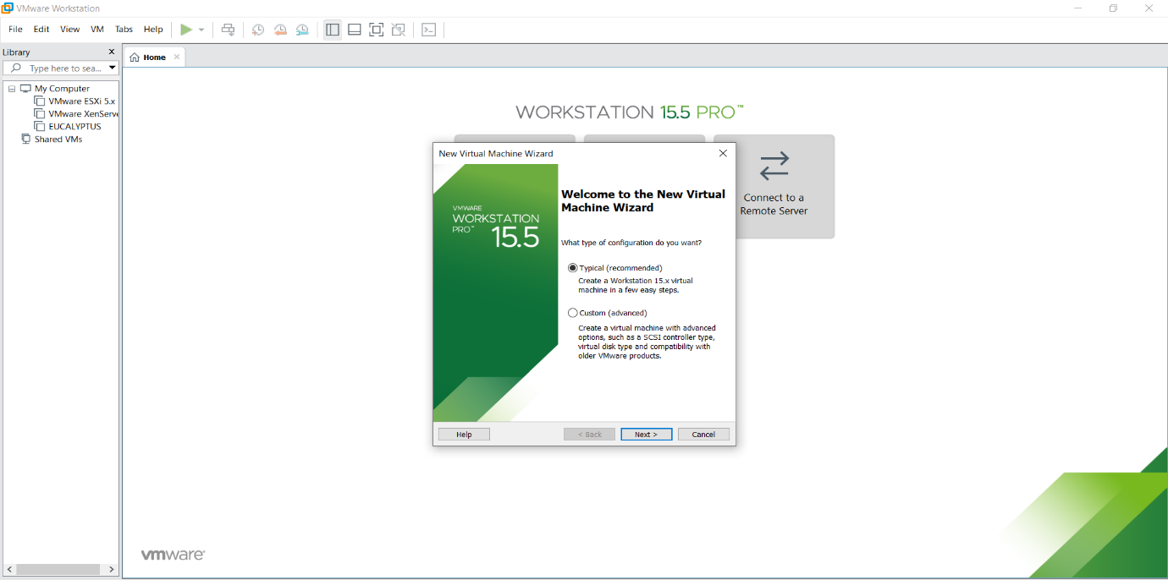

2) In the Next window, select the option **Installer Disc** and click on **Browse** to select the windows server 2012 iso file and then click on **Next**. In this window, select the name of **operating system** and its **version**.

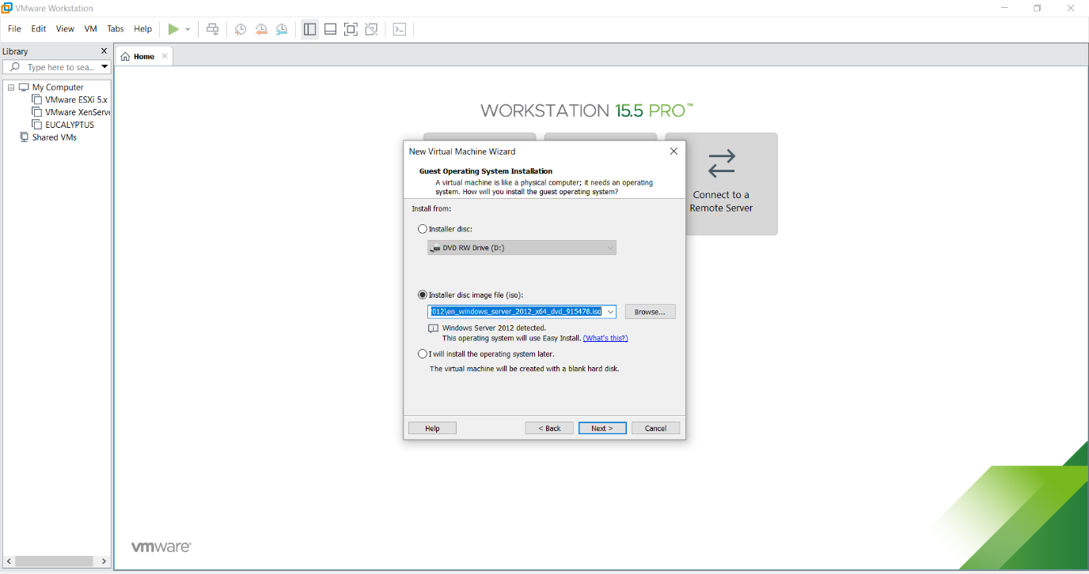

3) Click **“Next”**, And click on yes

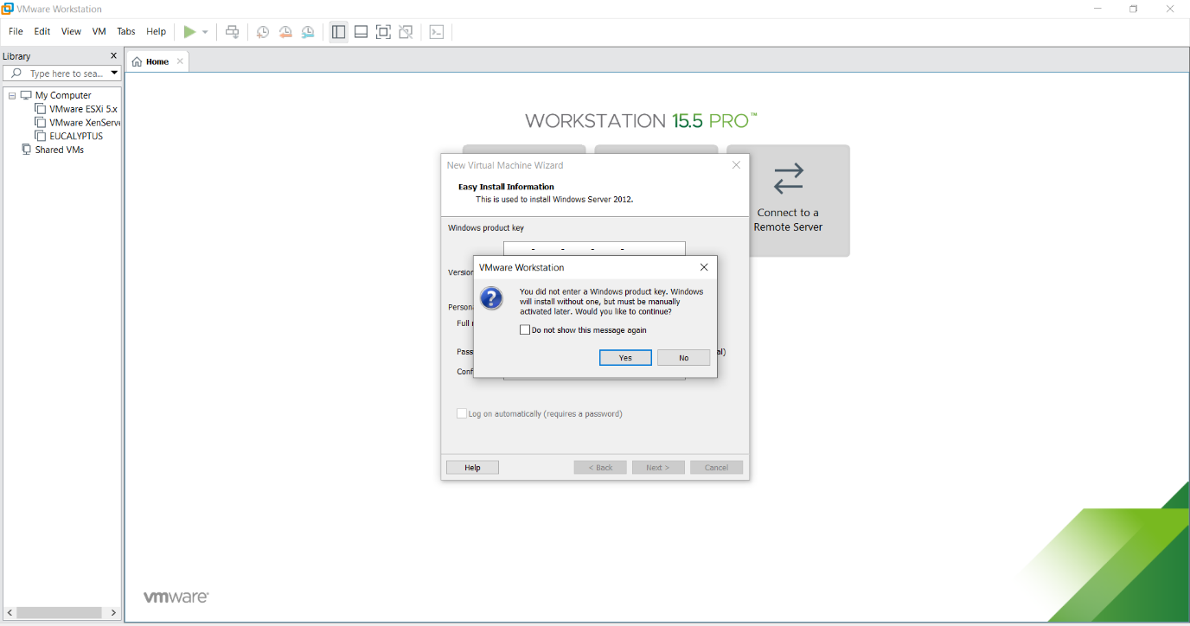

4)Name the Virtual machine

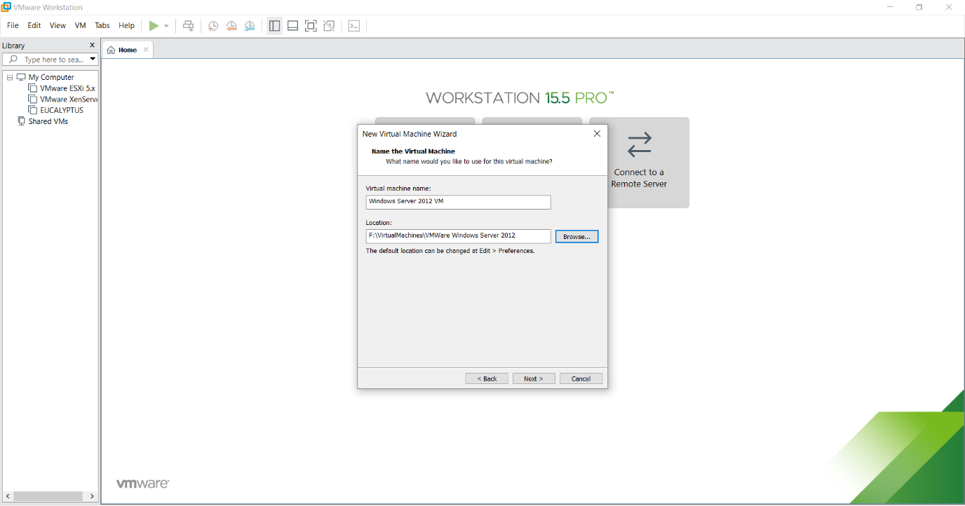

5) Choose **“Store virtual disk as a single file”** and Keep the memory size as **90GB**. Click on **“Next”**.

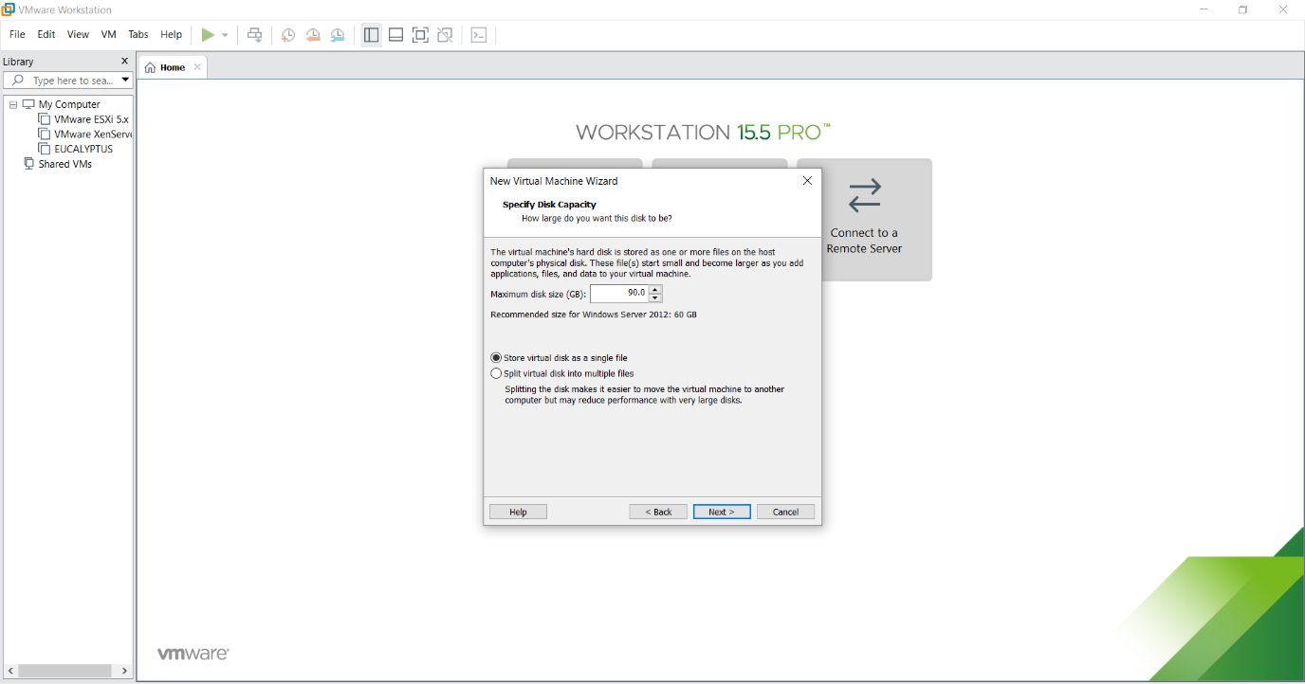

6)Click on **Customize Hardware** andclick on **Memory** under Devices on the right side and make it to **2GB**

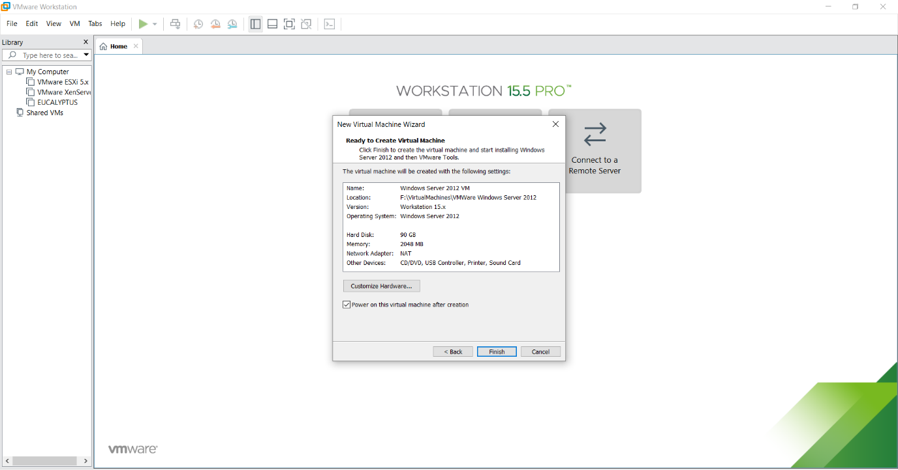

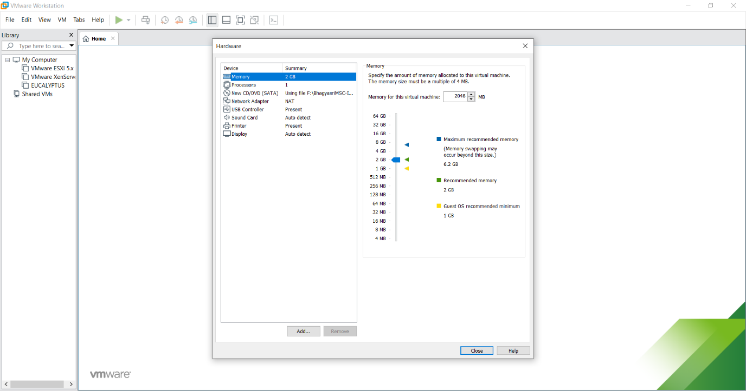

Click on Close and Power on the virtual machine by clicking on **“Power on this virtual machine”** and click on **“Finish”.**

Copying of **System Files** will start.

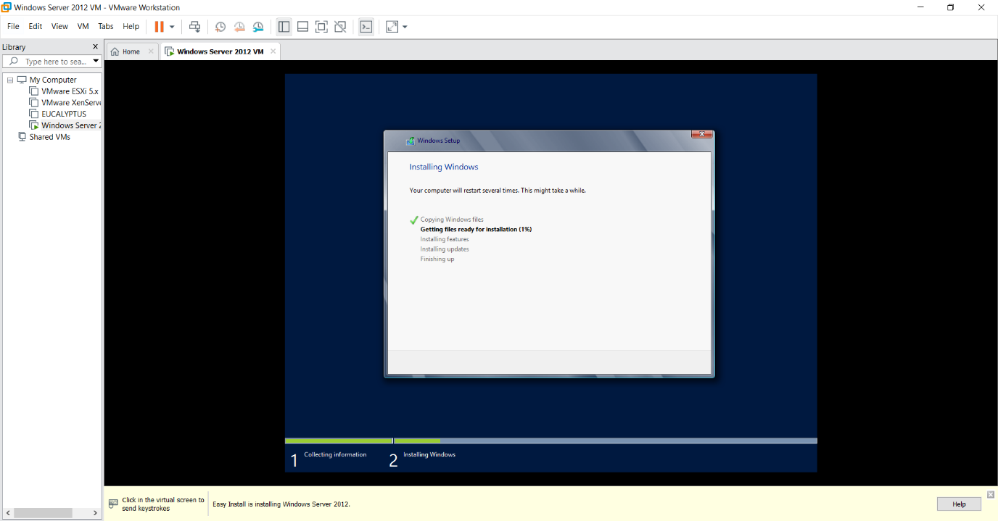

After copying files, it will automatically start.

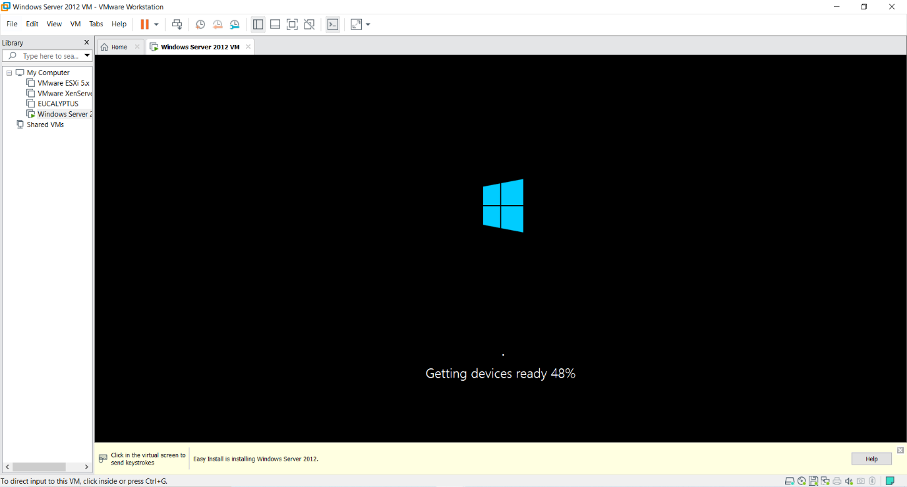

If prompted to restart the machine for the changes that needs to be applied then click on **Yes.**

After restart you will see the below screen.

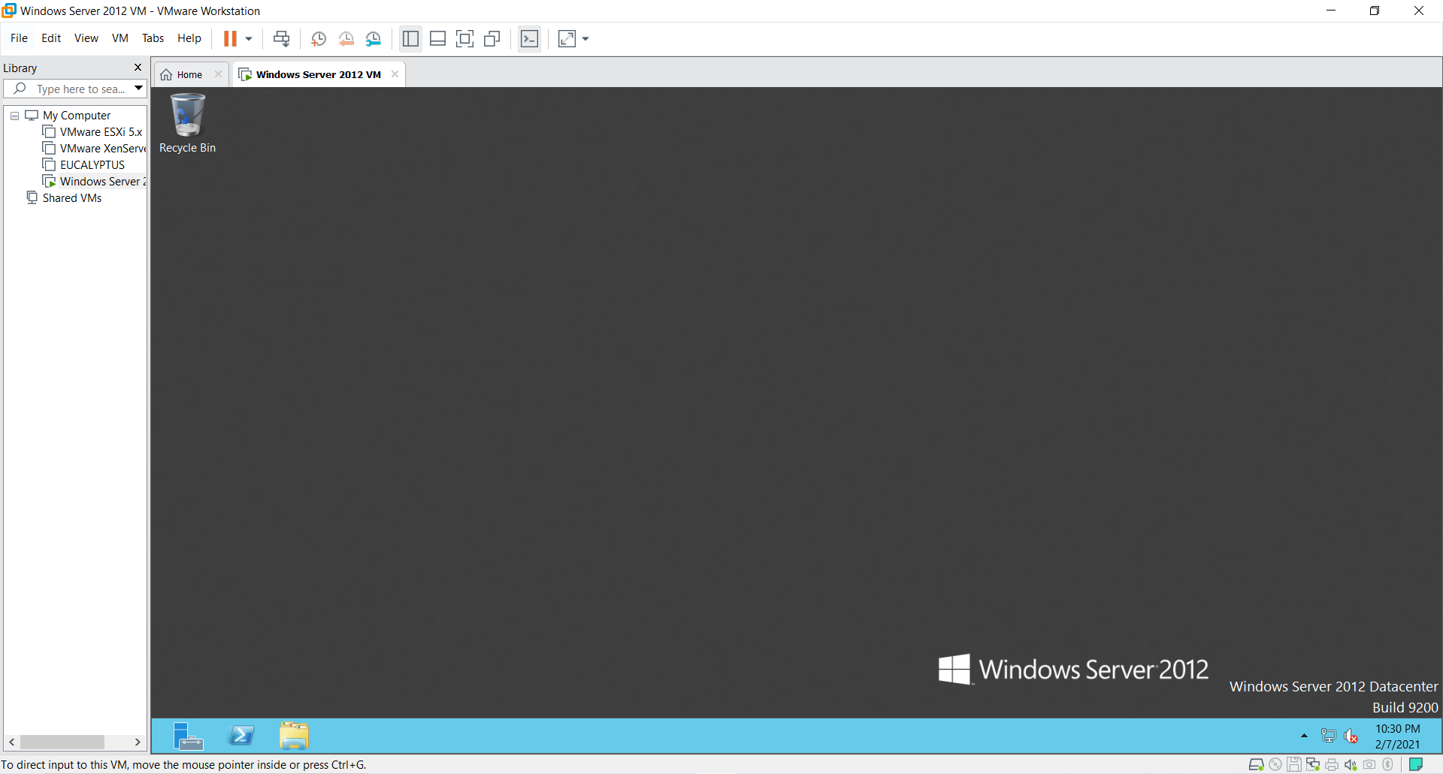

7) If installing on the Virtual Machine like VMWare then you need to click on the menu as shown in the next screen.

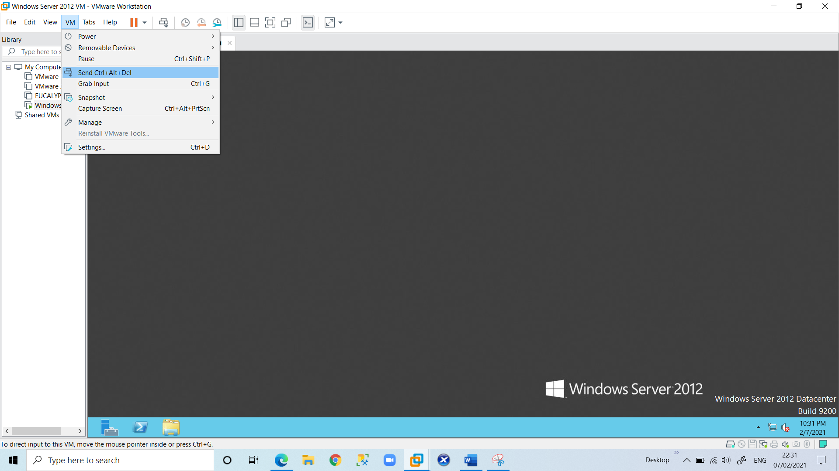

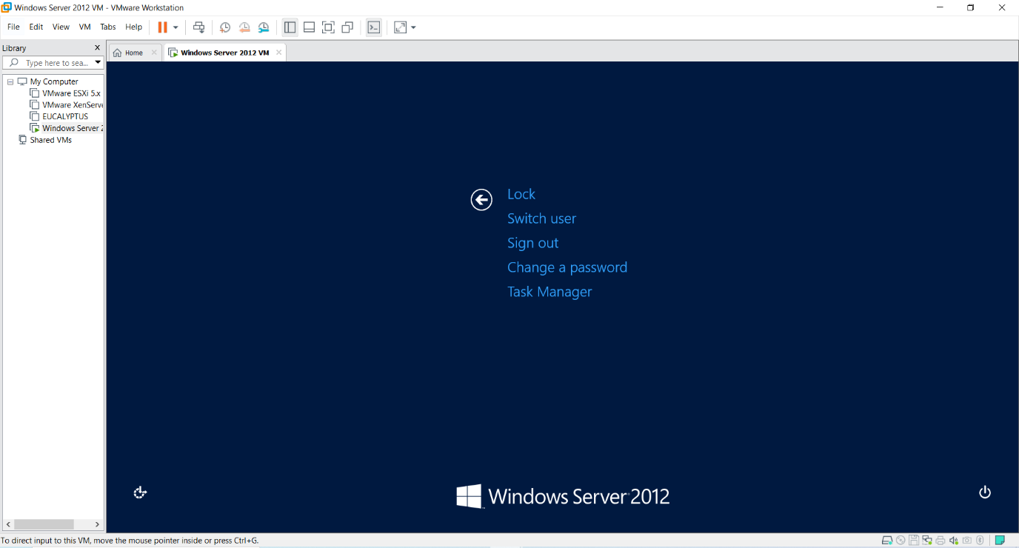

Click on **Switch User**.

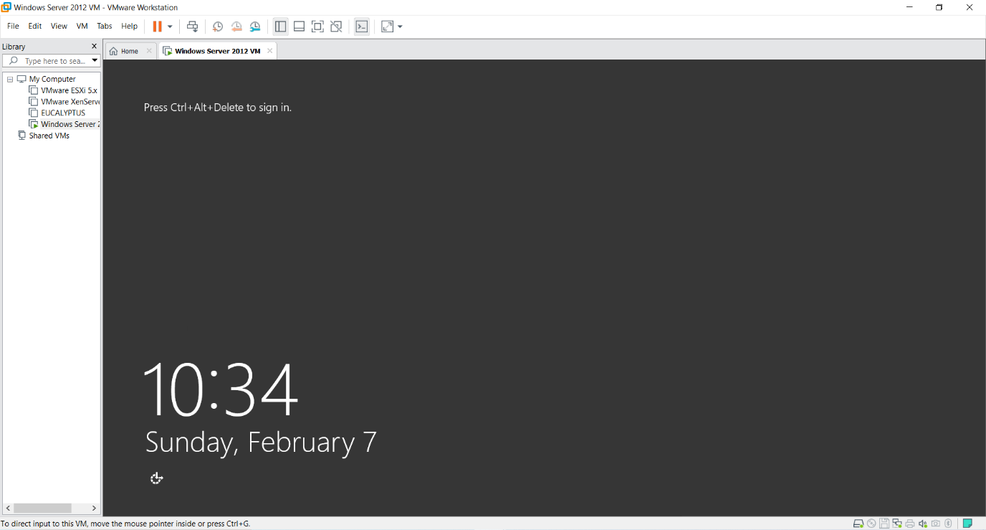

Click on **Ctrl+Alt+Delete** and click on **Administrator**.

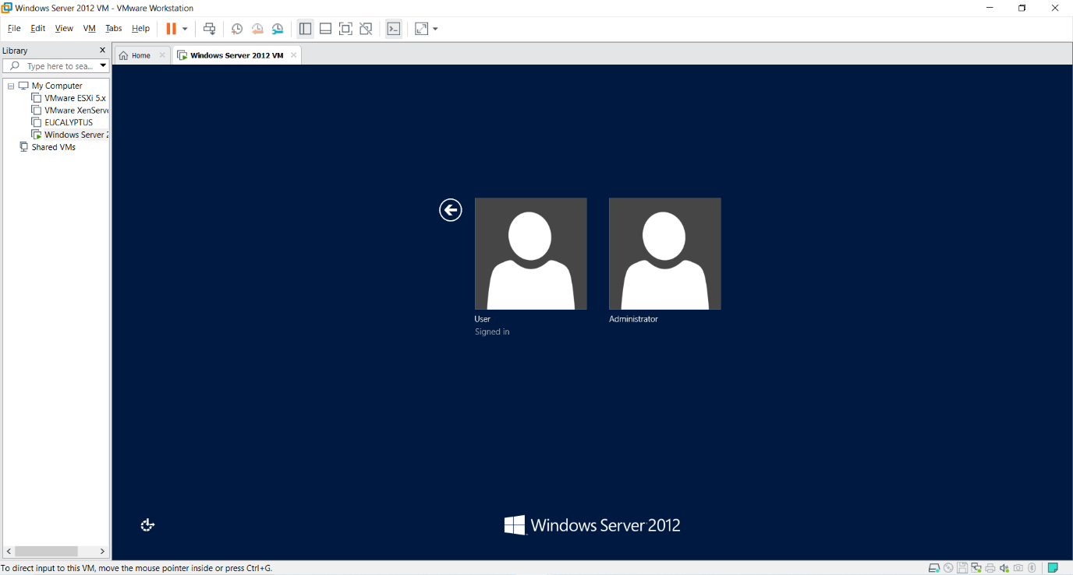

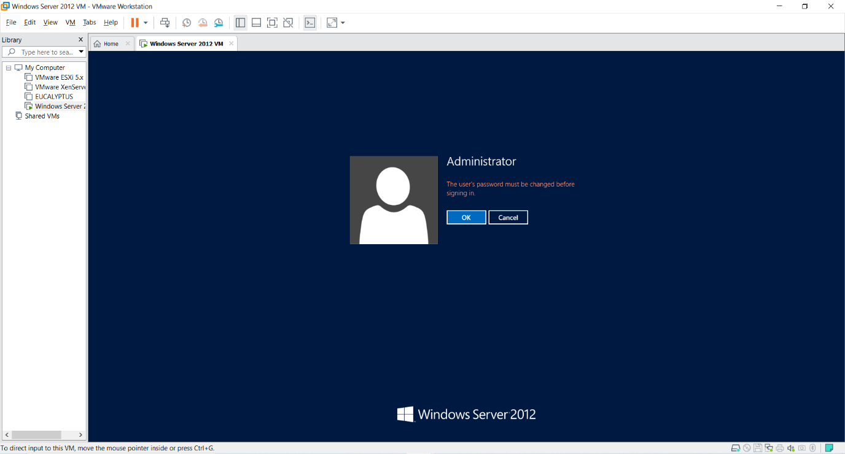

Click Ok.

Enter the new password “**Admin12345**” and press **“->”** button.

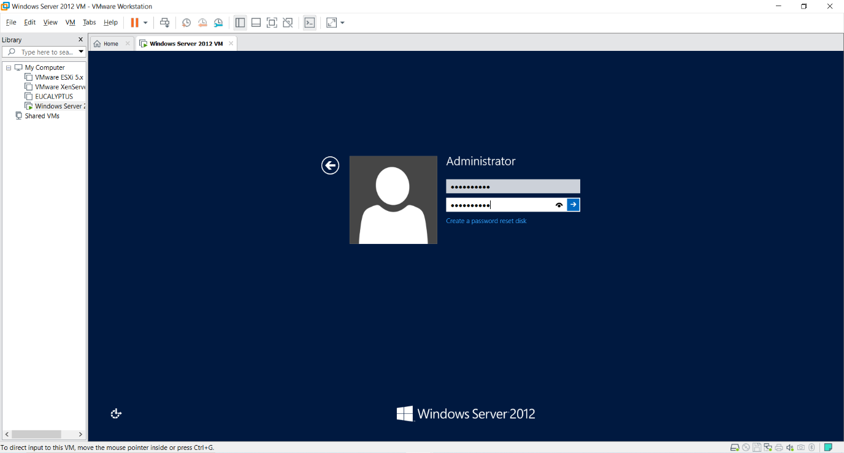

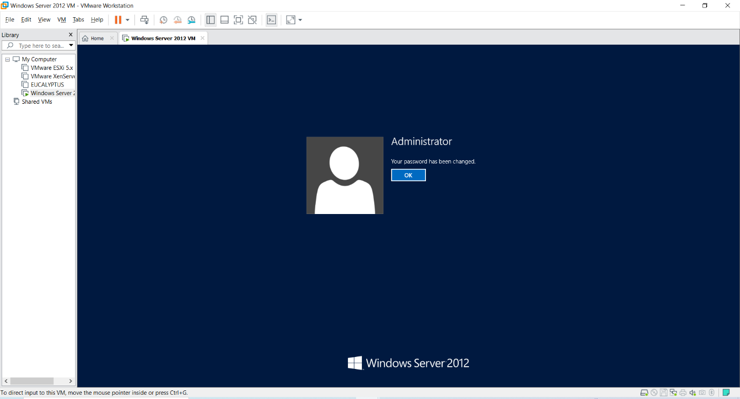

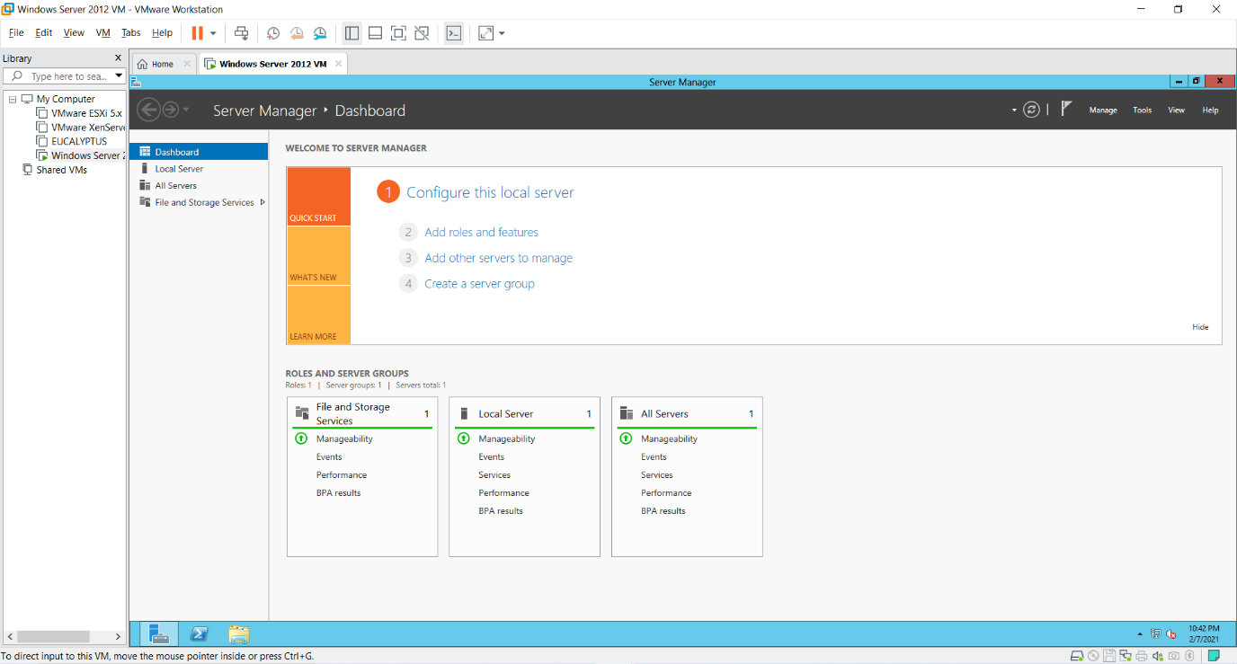

8) To make the current system a Domain Controller click on **“Add Roles and Features”** under the **“Manage”** menu at the top of the screen and get the **“Add Roles and Feature Wizard”**.

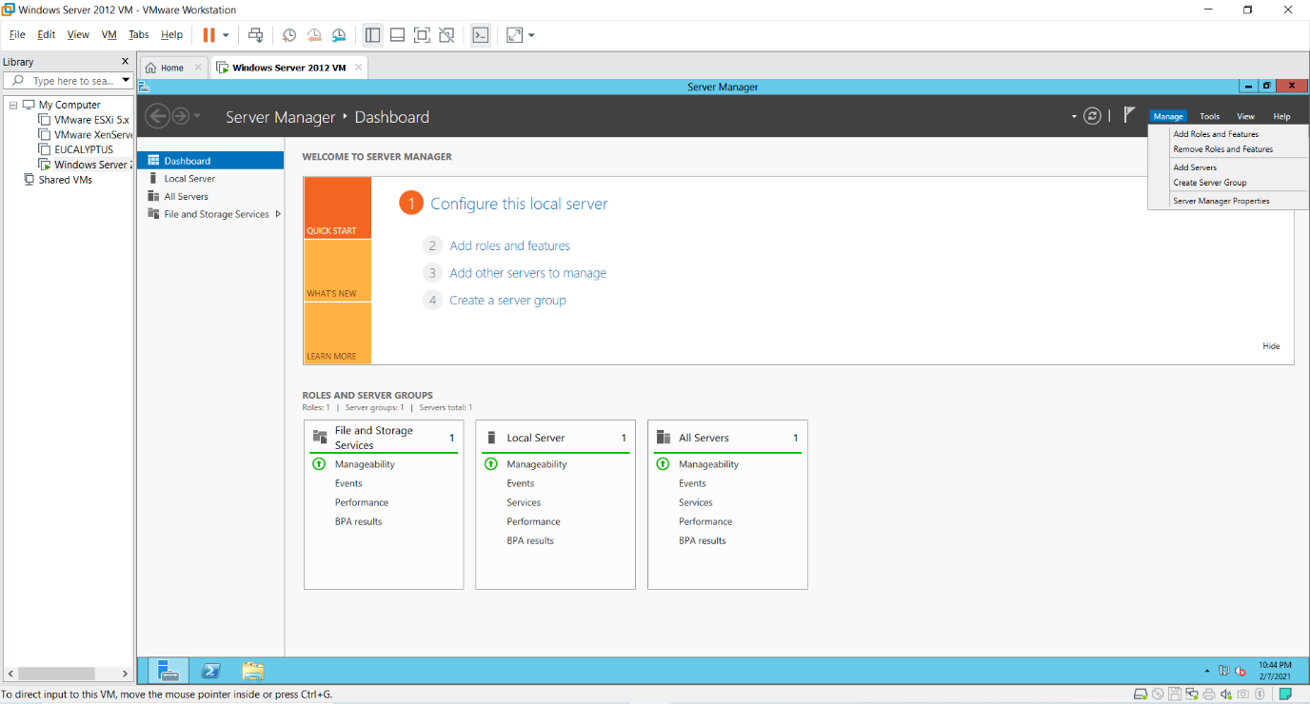

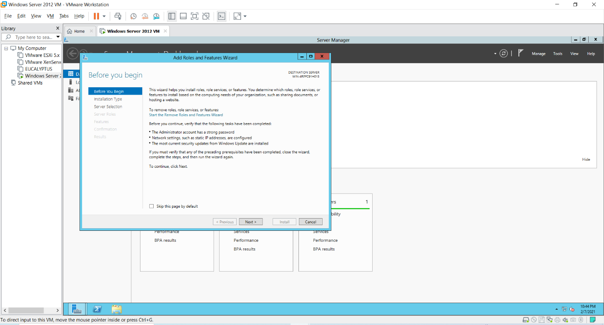

9) Under **“select installation Type”** select **“Role-based or feature-based installation”** and click **“Next”** button.

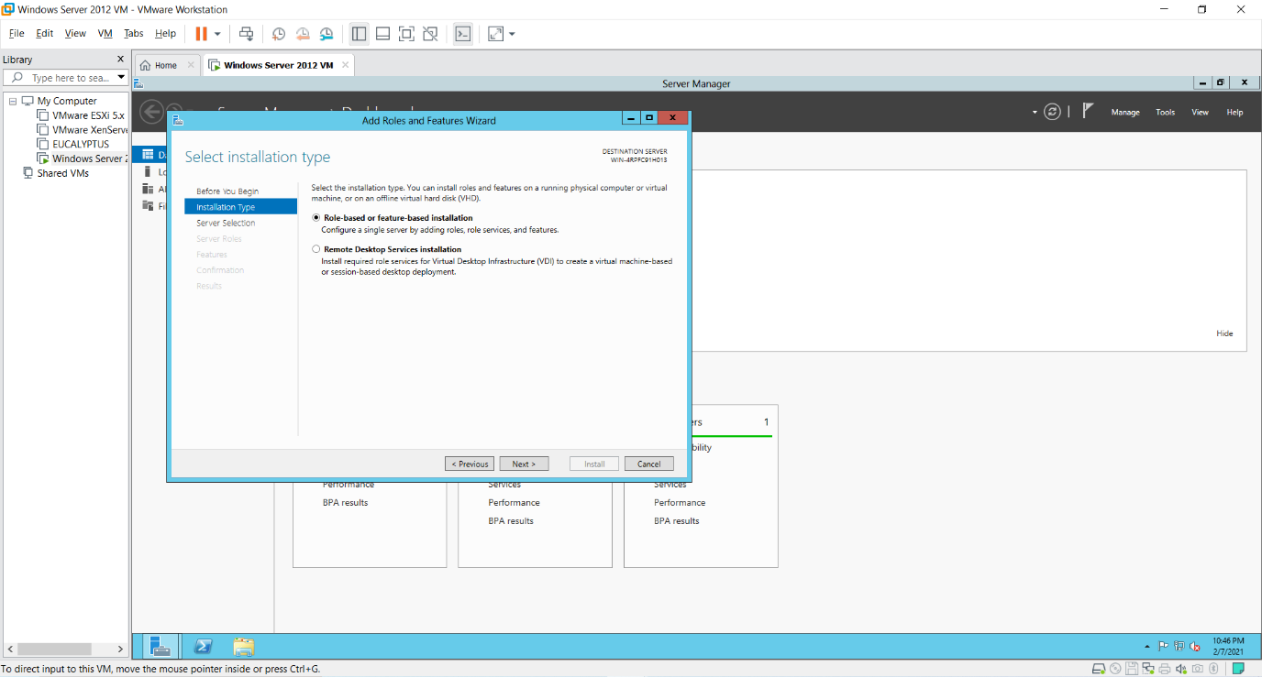

10) Under **“select destination Server”** select **“Select a server from the server pool”** option and select the server as shown in the screen below and click **“Next”**

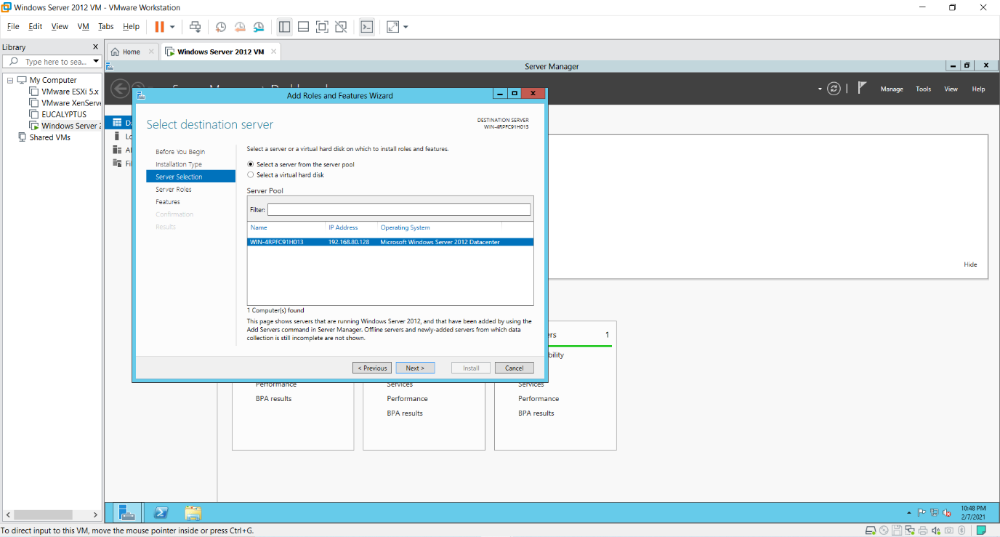

11) Click on **“Active Directory Services”, “DHCP”** and **“DNS”** roles from the list of roles provided and click on **“Add Features”** button as shown in the screen. Add Features button will appear as you click on any of the roles. After selecting the Role click **“Next”**.

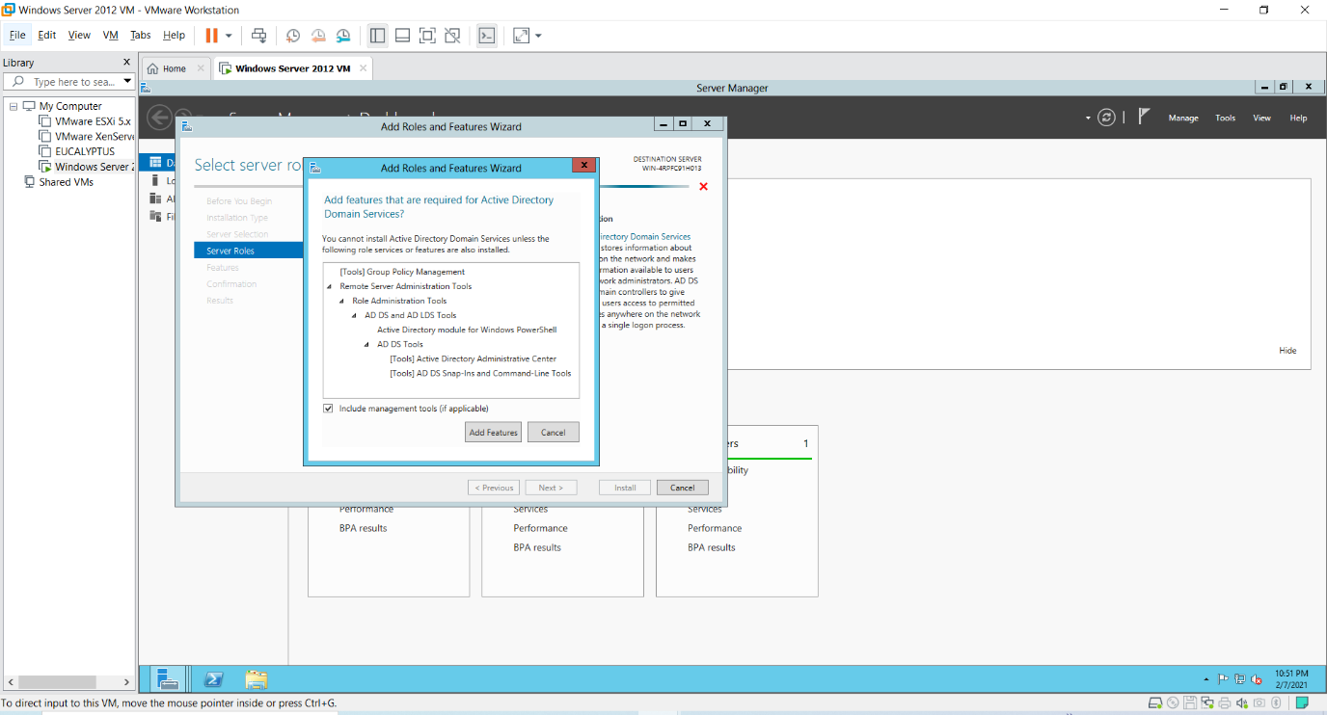

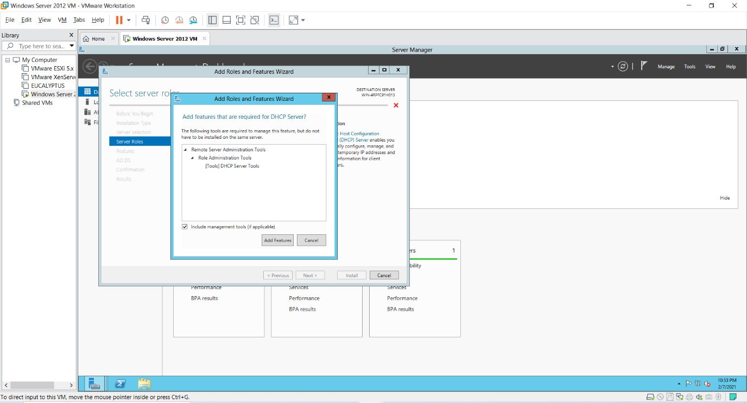

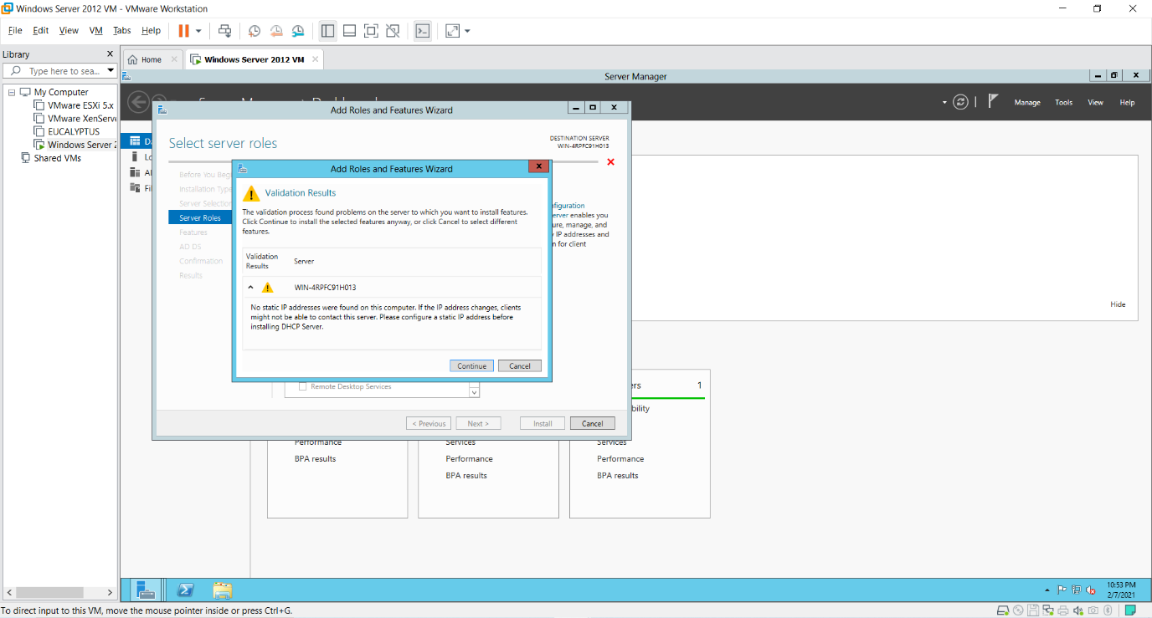

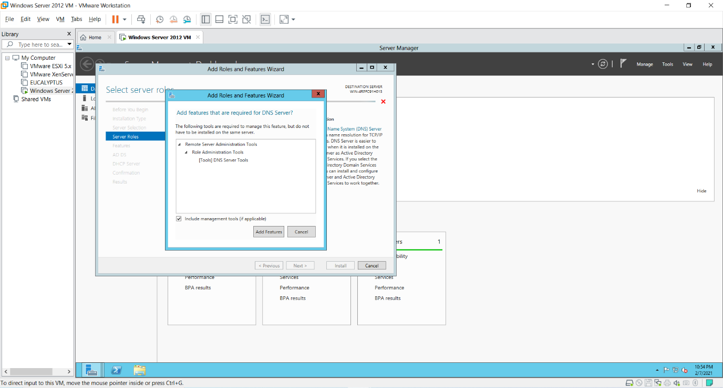

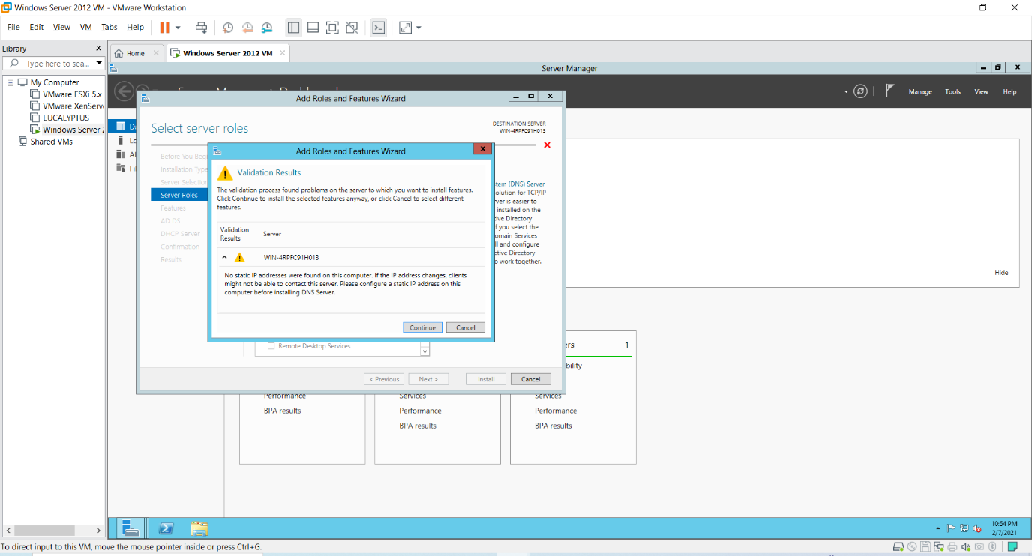

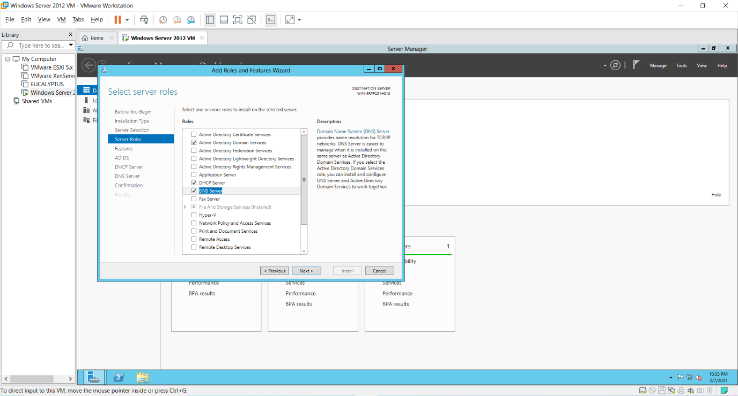

12) Under **“Select Features”** select **“Failover Clustering”** and **“.NET Framework 3.5 Features”** and click **“Next”**.

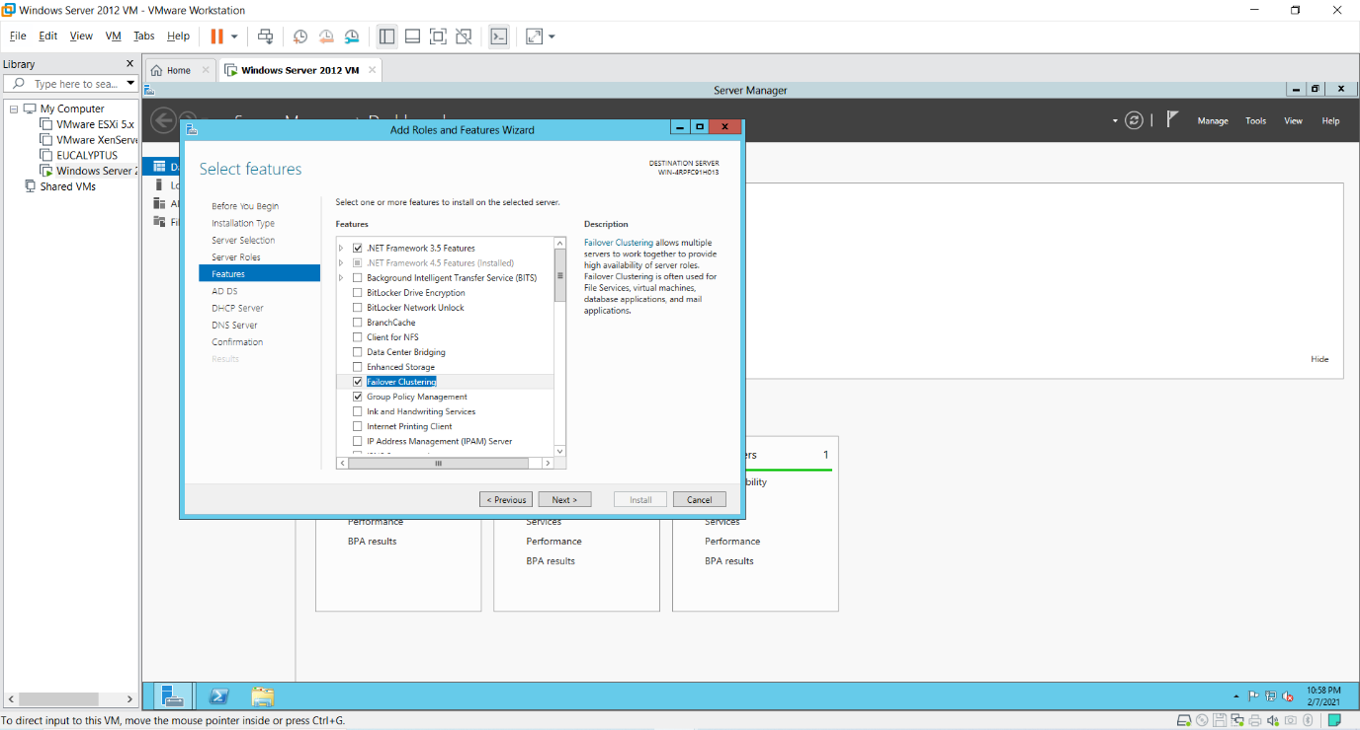

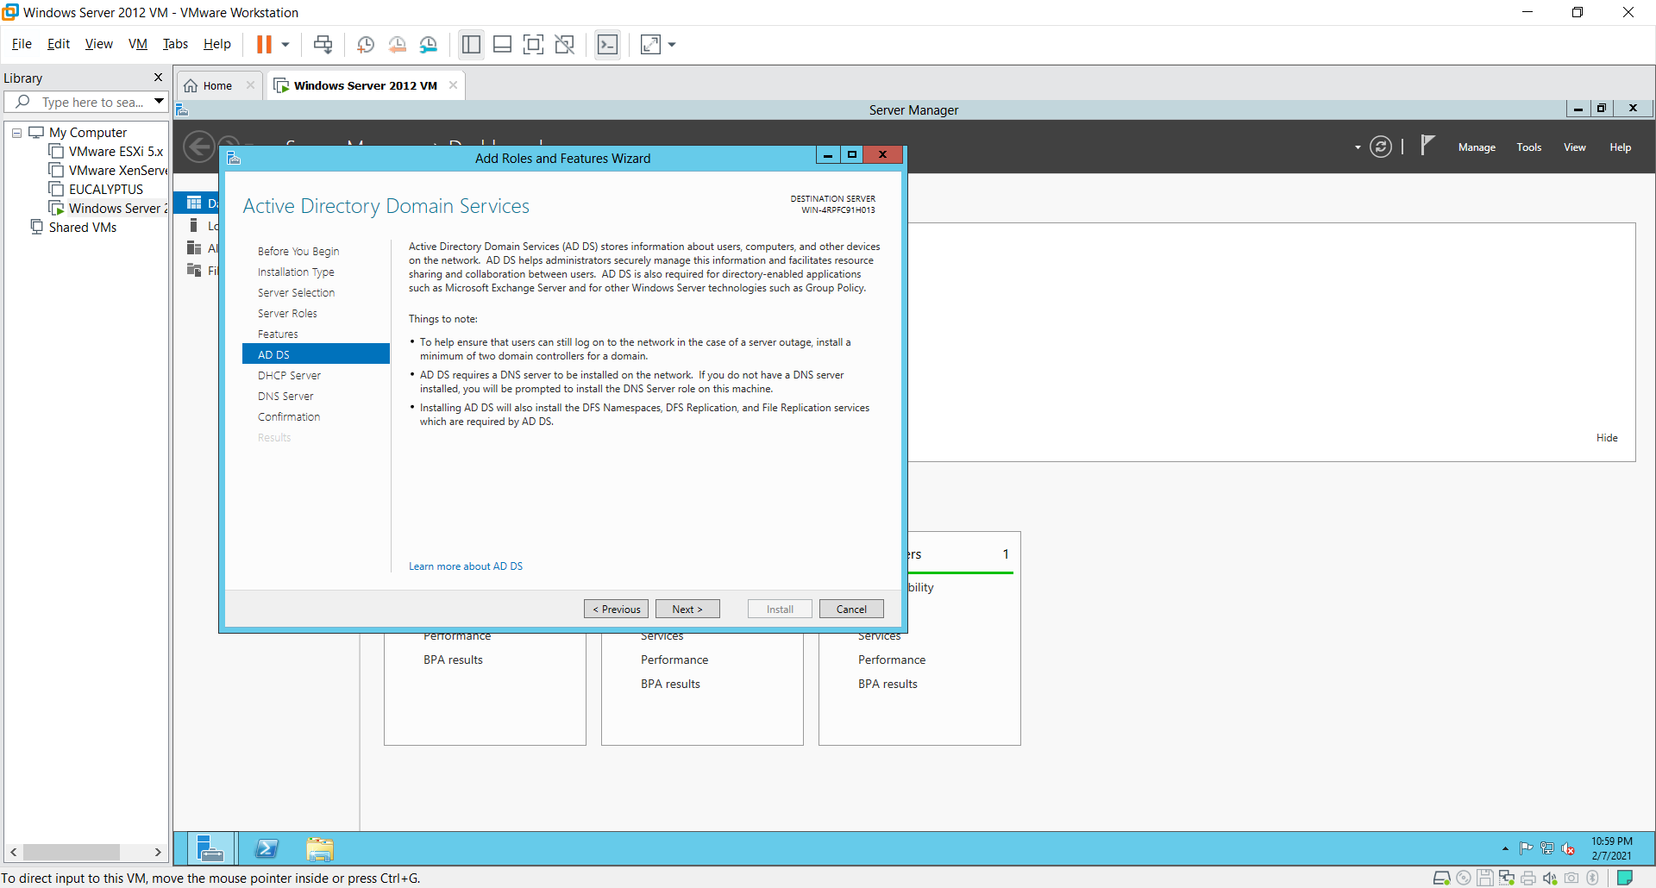

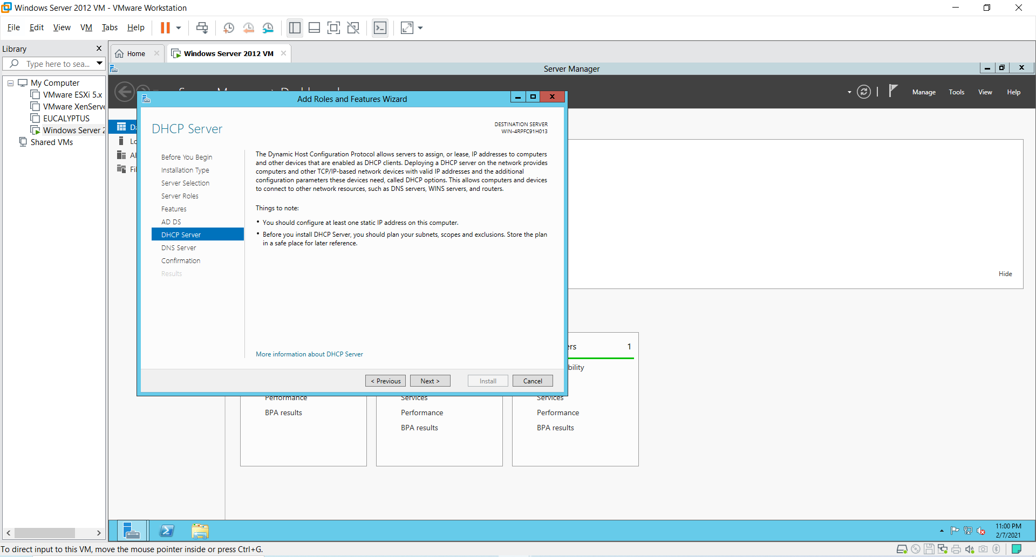

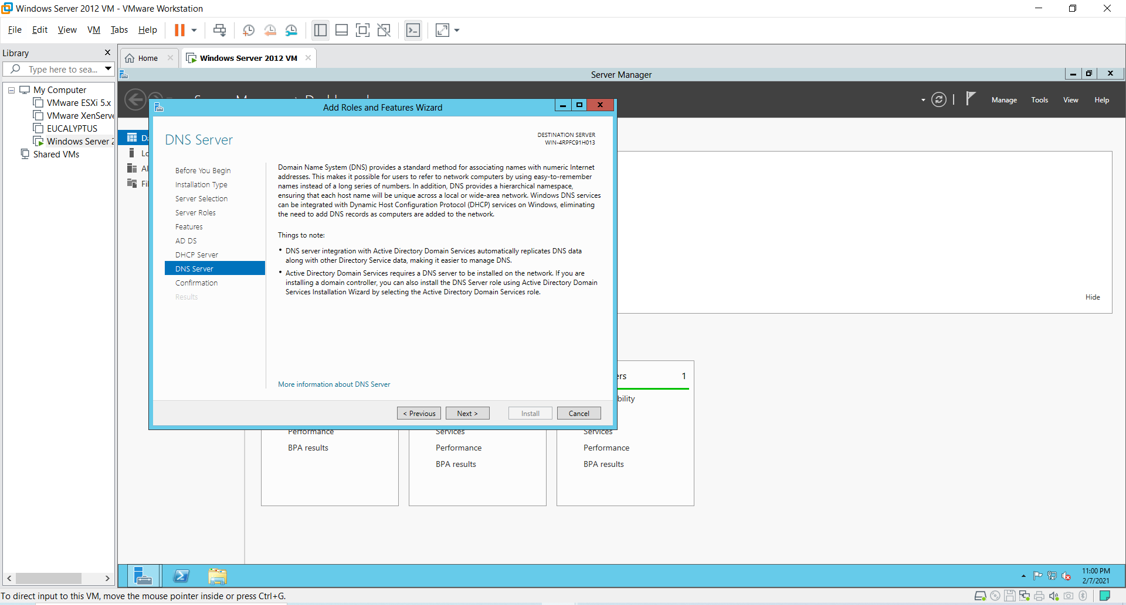

13) You will see the **“Confirm Installation selections”** then click on the checkbox **“Restart the destination server automatically server if required”**.

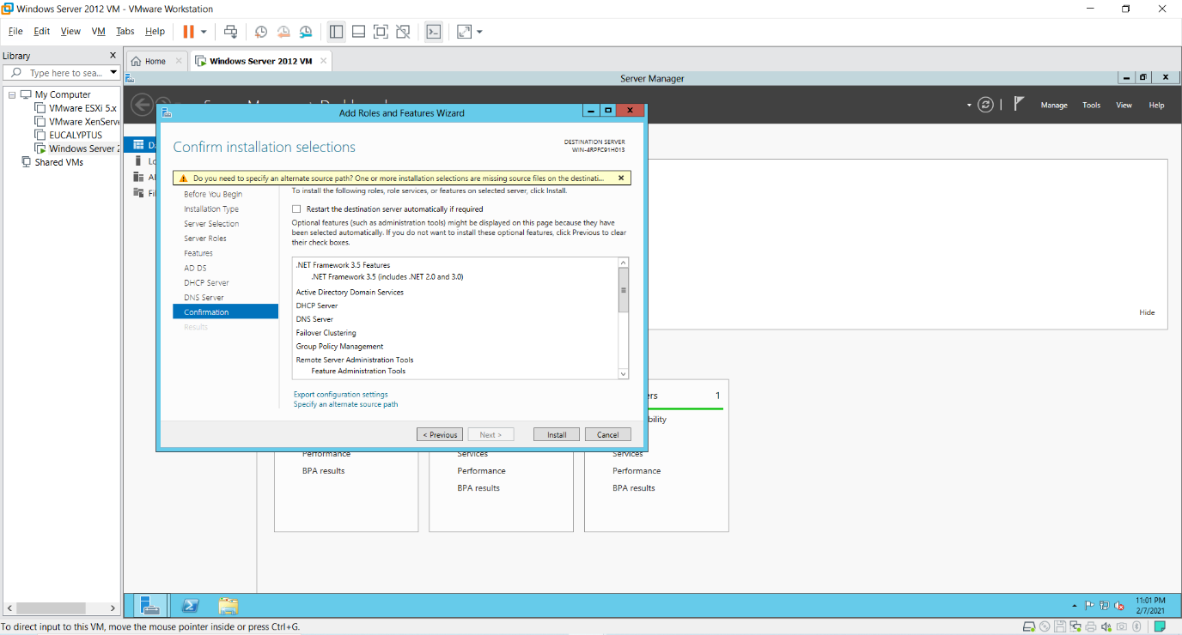

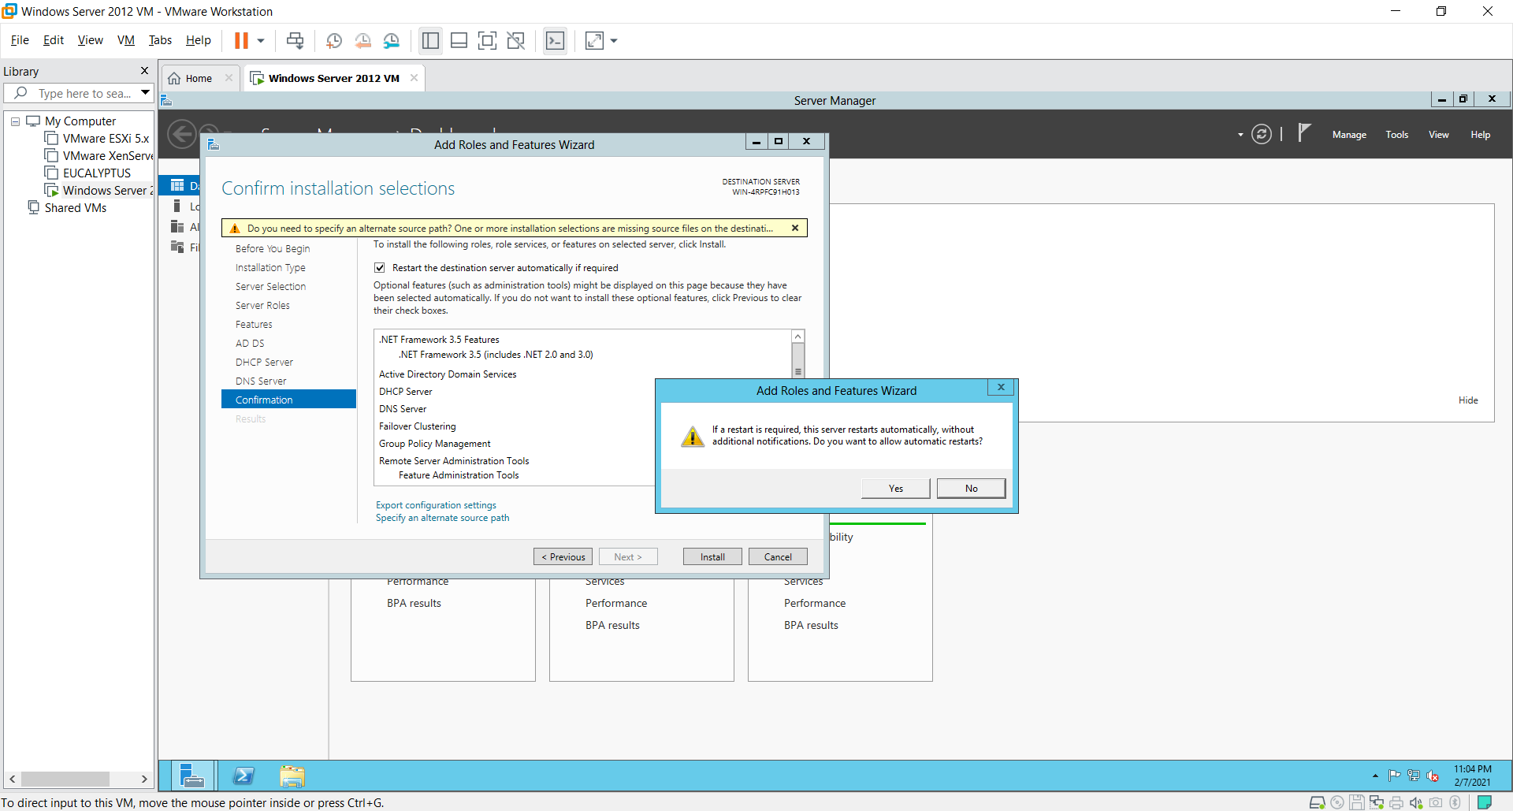

14) Click on link **“specify an alternate source path”**. As shown in below two screens.

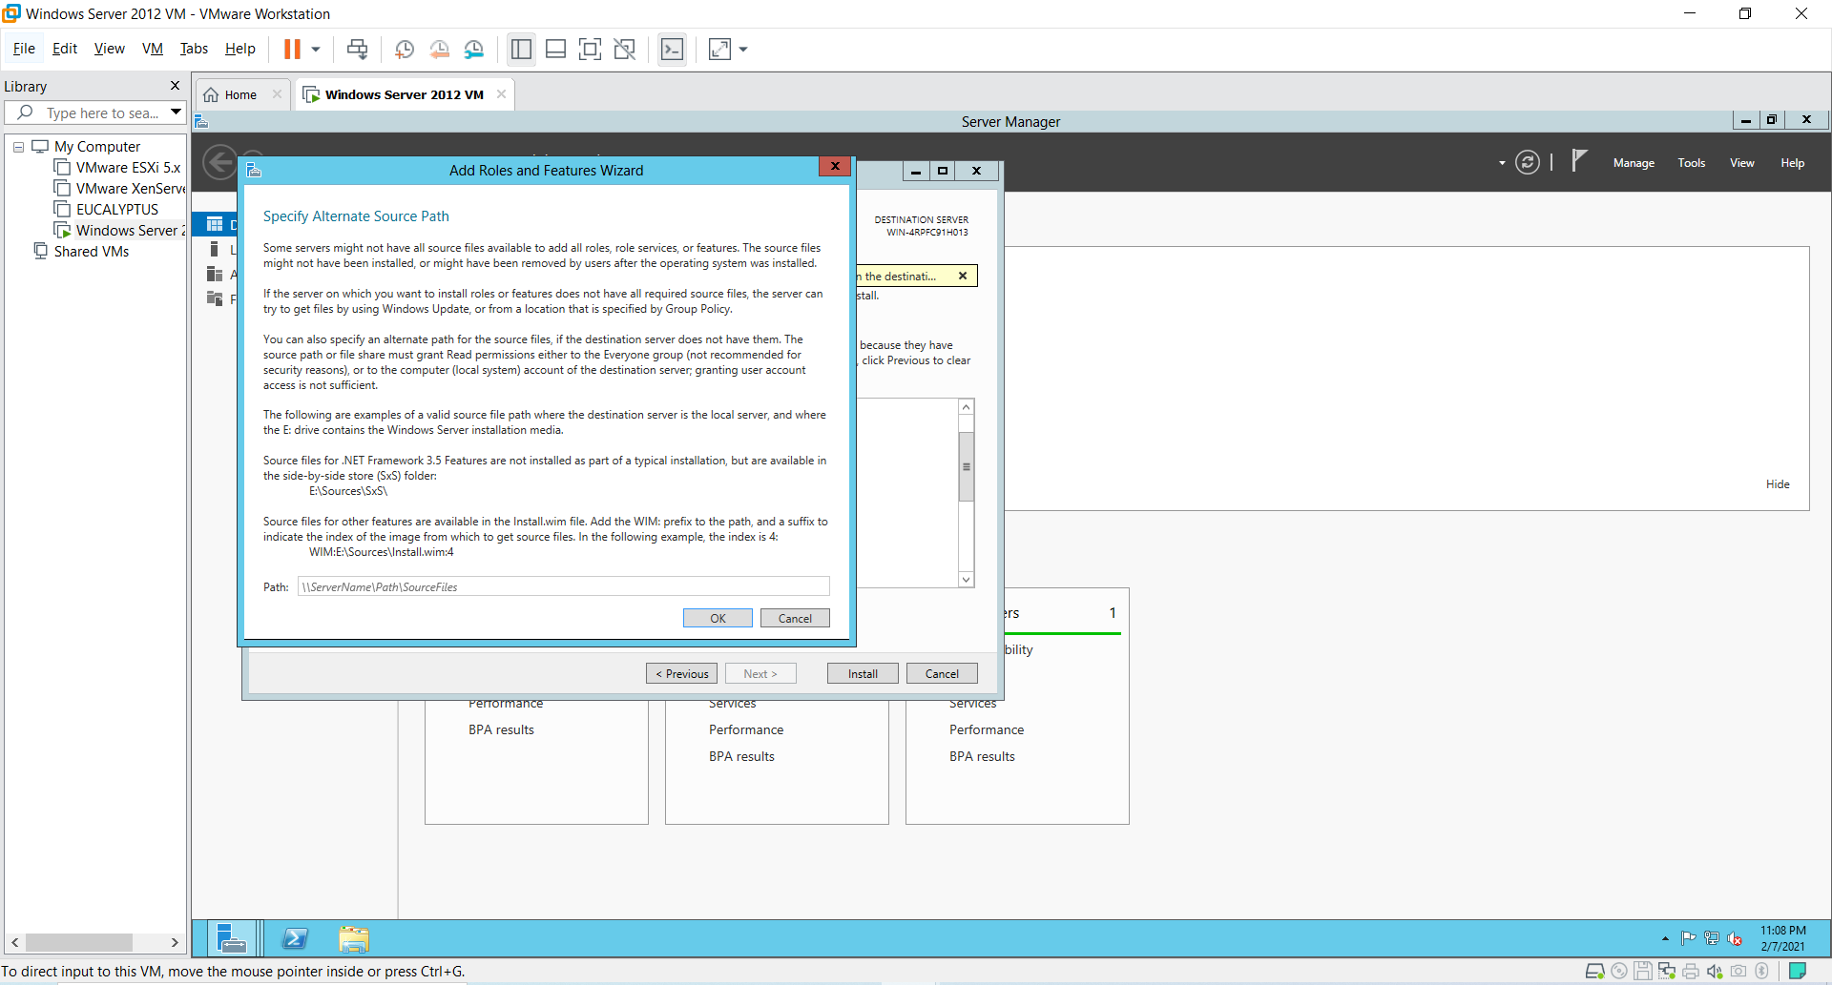

Now, for path specification Go to menu **VM->Settings->use Iso image file of windows server 2012**, click checkbox **Connected** and **Ok**. Then, Go to **File Explorer->Computer -> select the DVD->VIEW FILE-> SOURCES->SXS**.

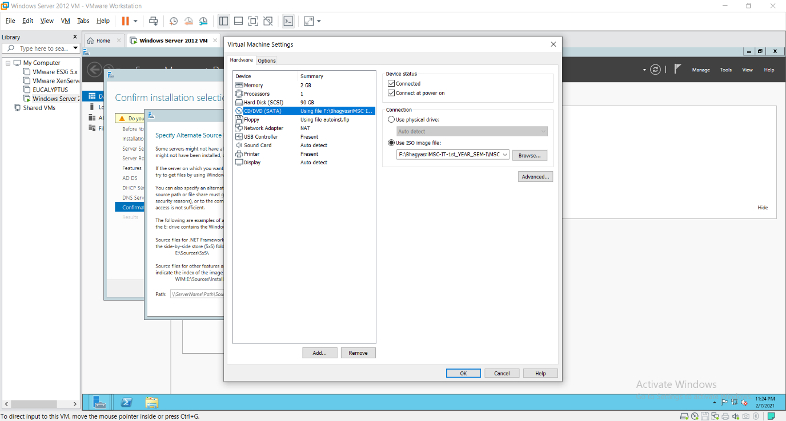

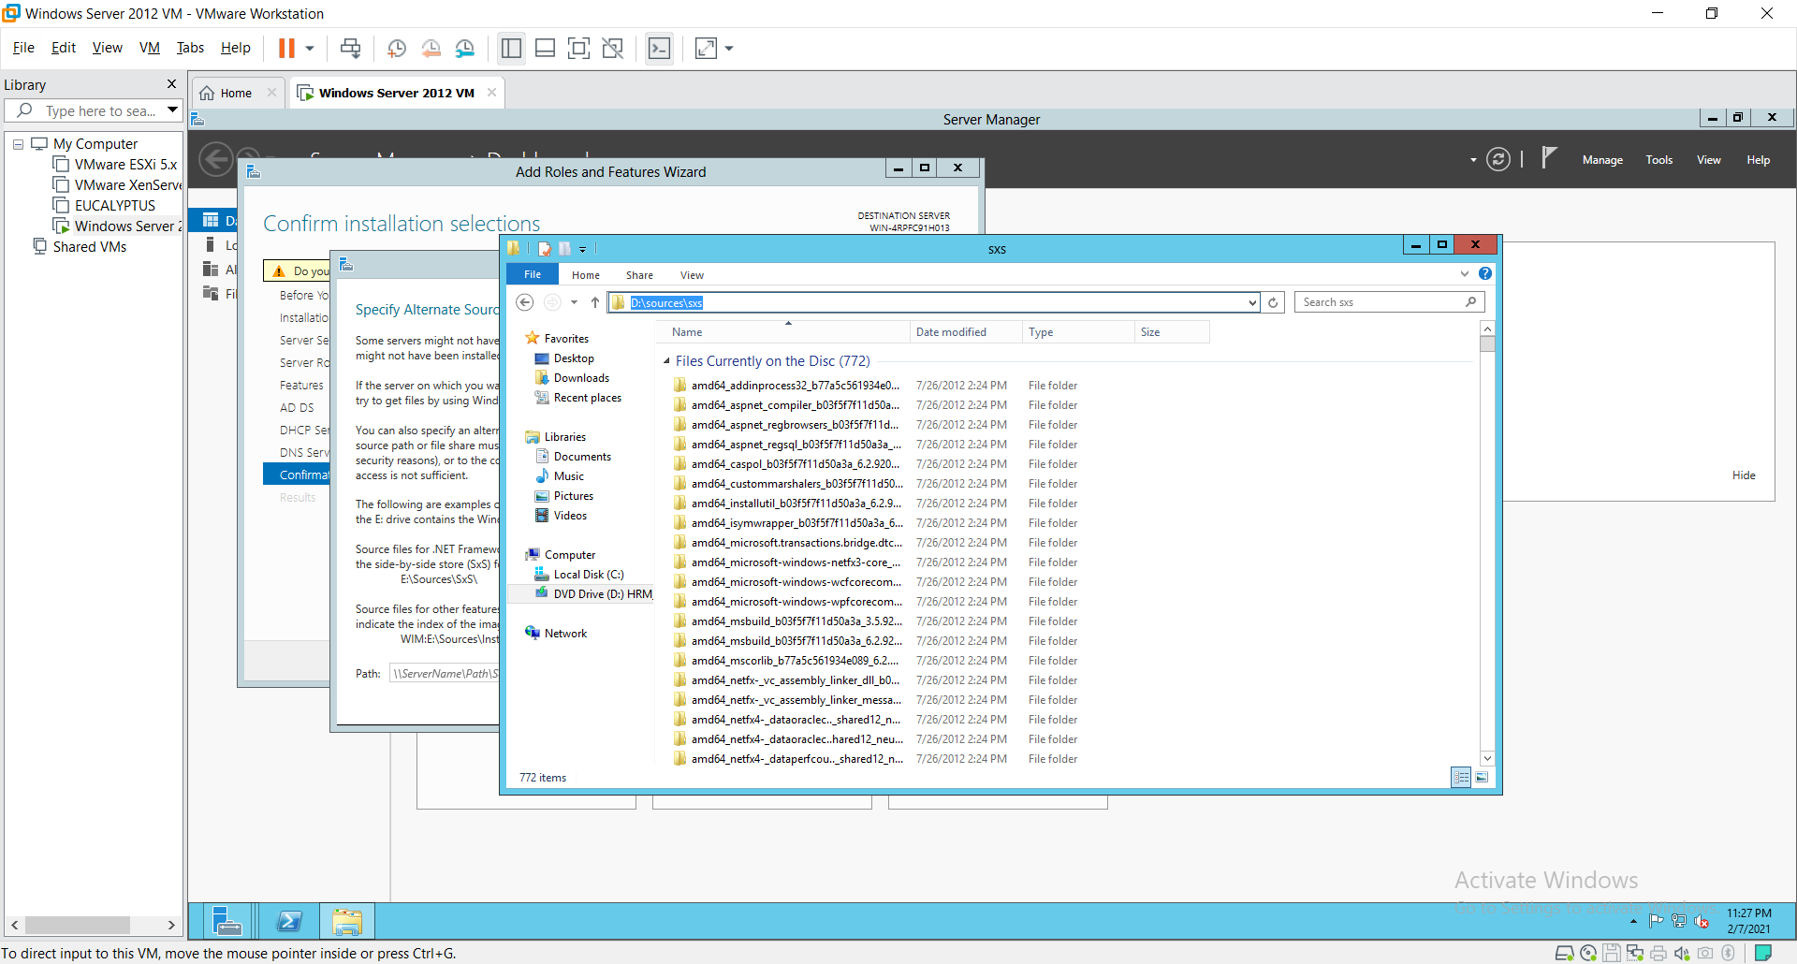

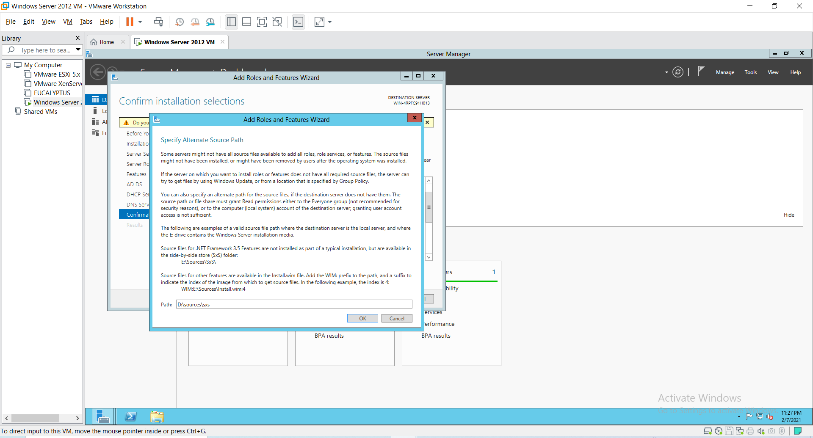

15) Now, click on ok and Install button.

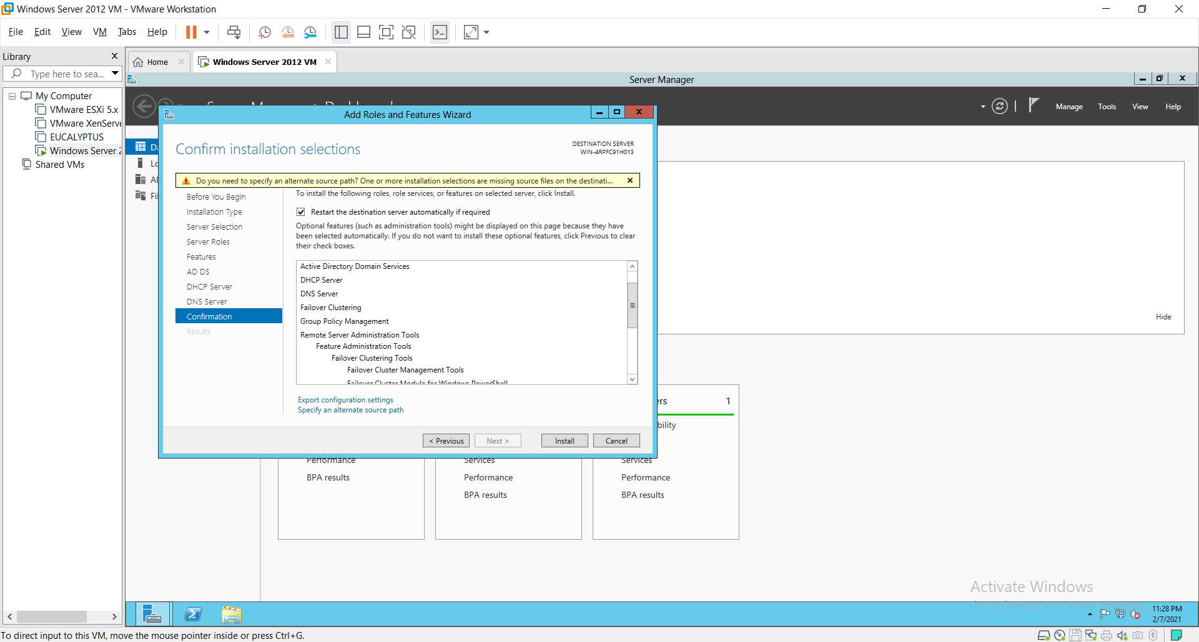

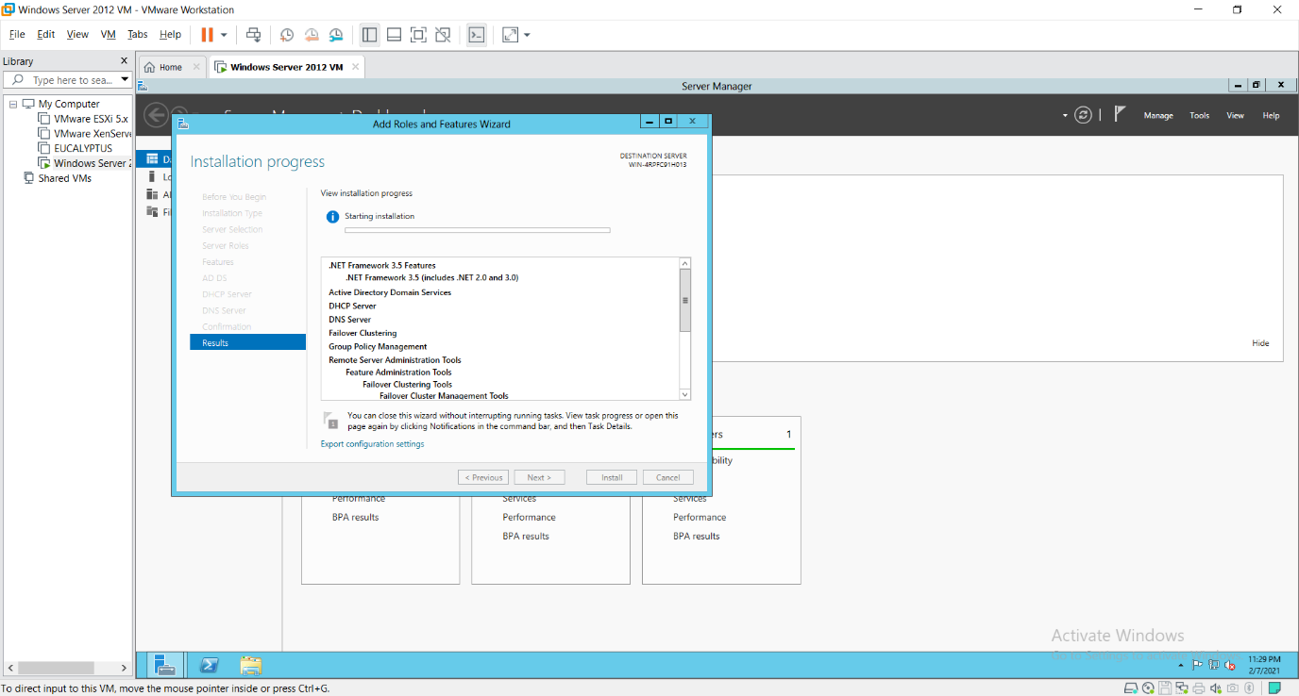

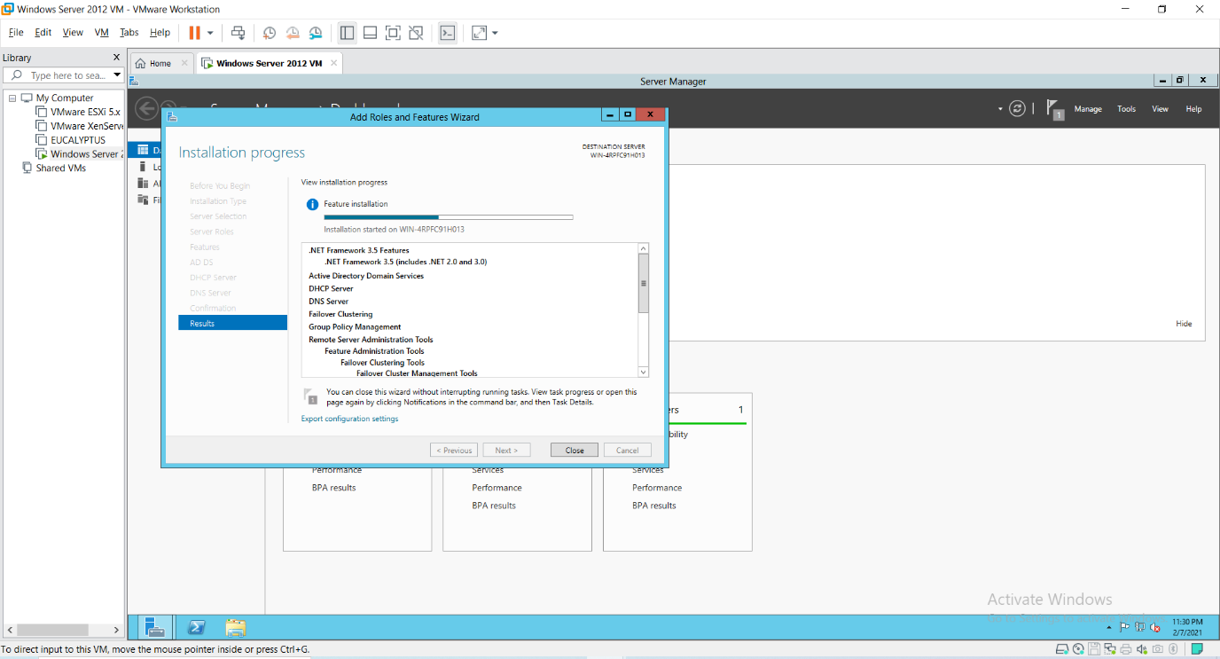

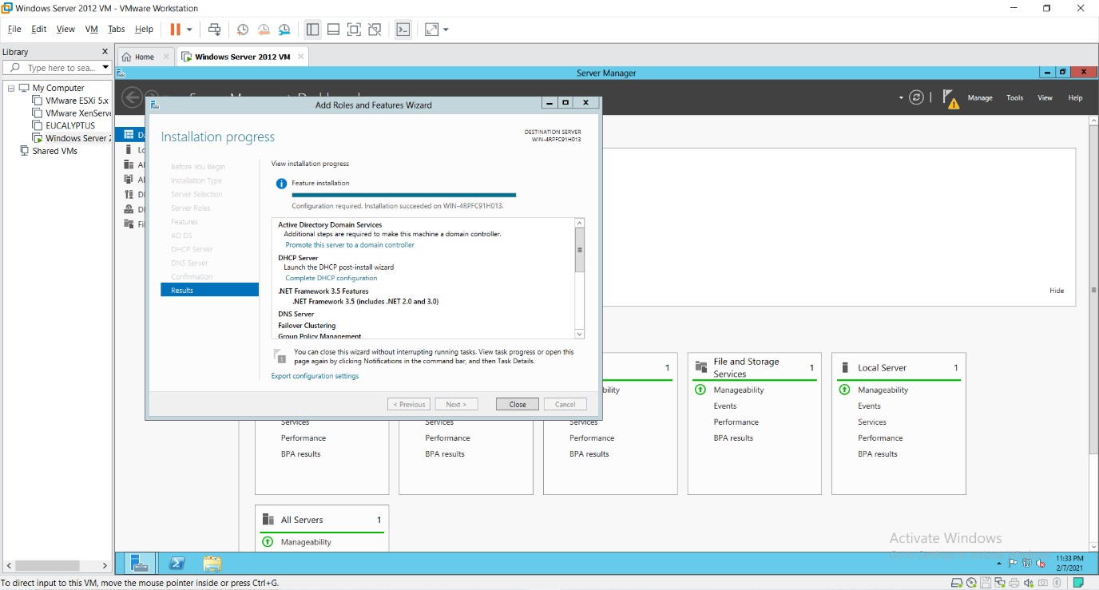

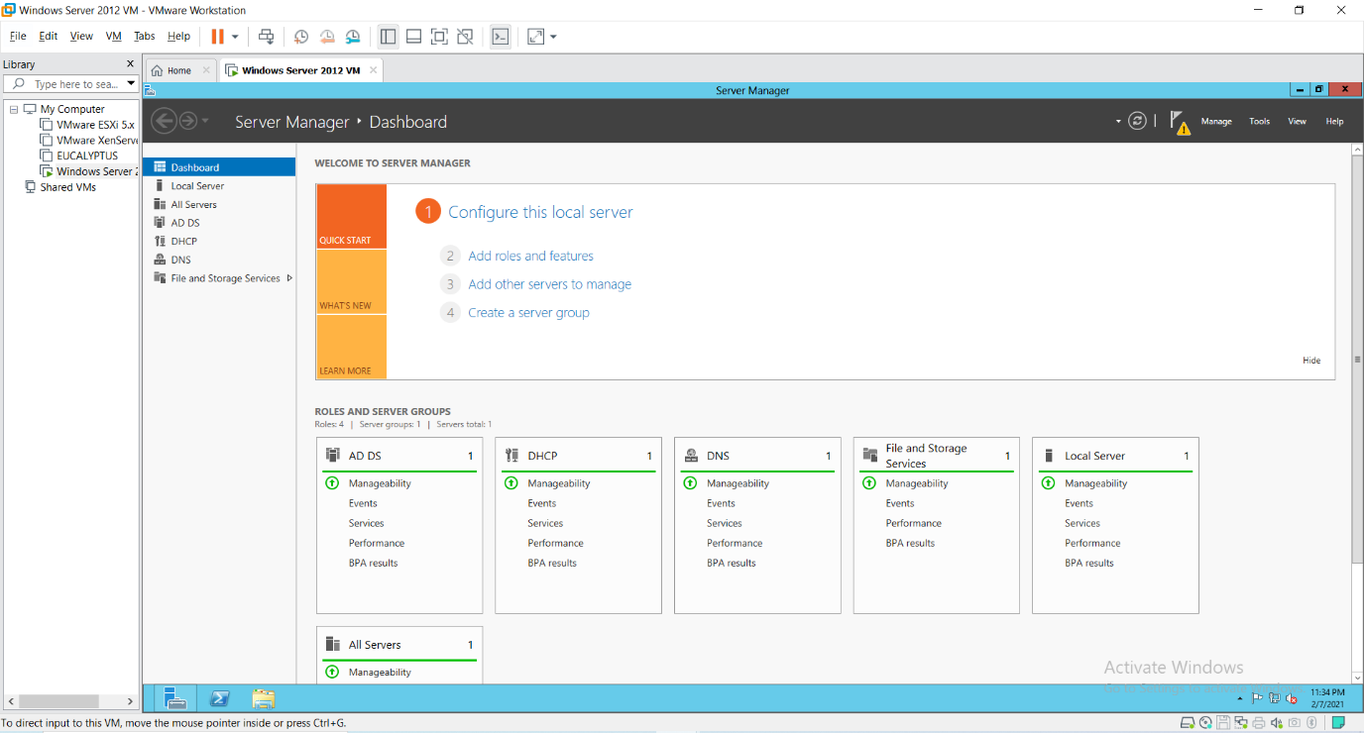

16) PROMOTING AS DOMAIN CONTROLLER After installation Go to the “AD DS” shown on the left side in the server Manger Dashboard as shown in next screen and click on More, then Click on “Promote this server to a domain controller”.

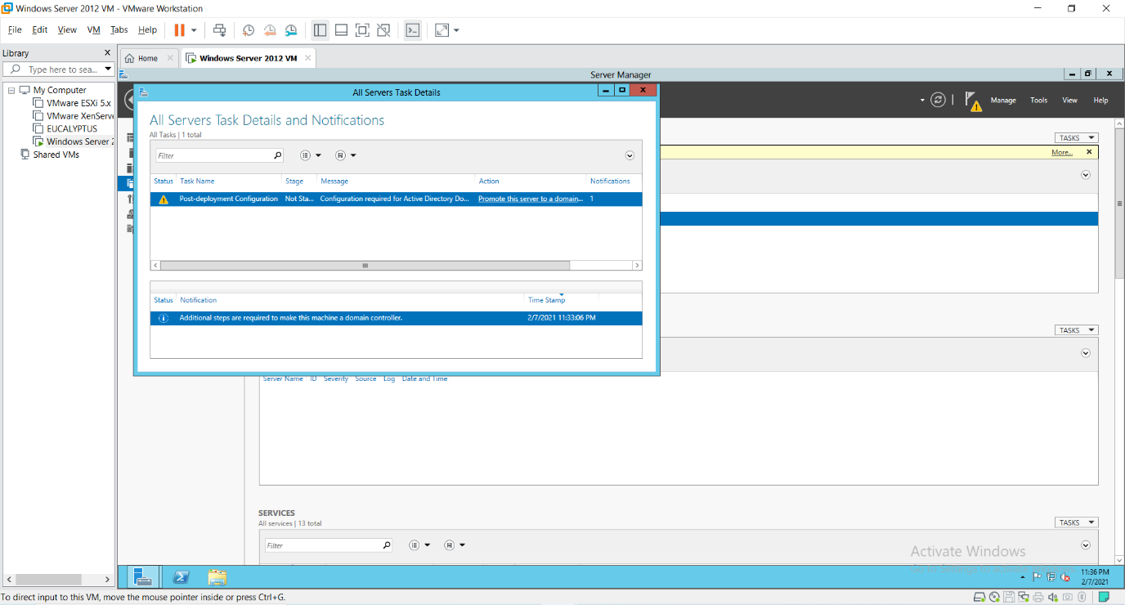

Choose **“Add a new forest”** option in the **“Active Directory Domain services Configuration Wizard”** window. Enter the Domain Name **“rjcollege.com”** as shown in the screen and click **“Next”**.

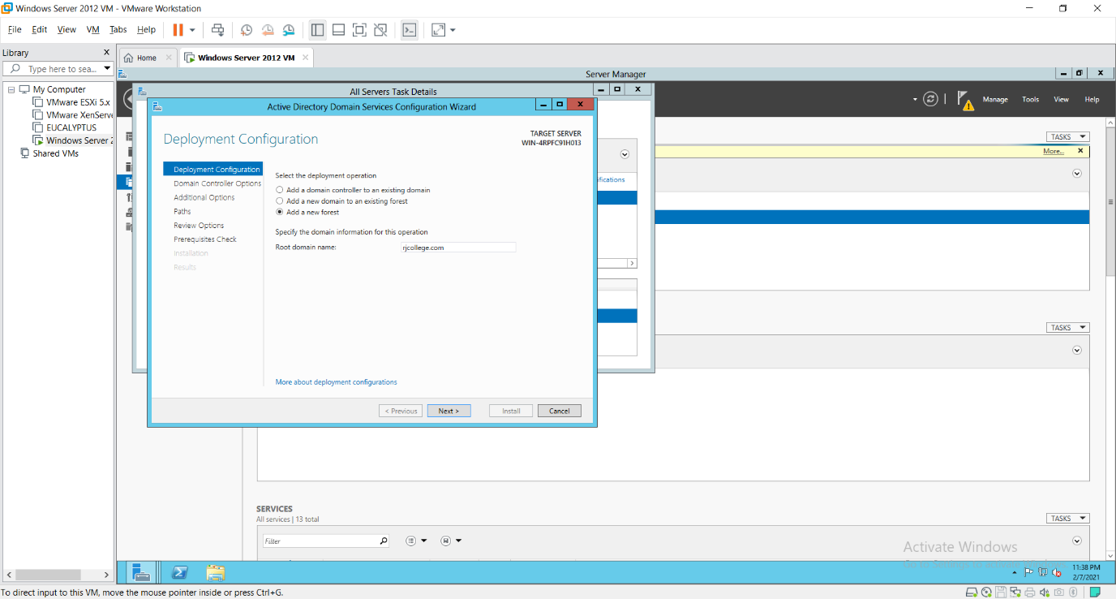

Under **“Domain Controller Options”** enter the alphanumeric password for the **“Directory Services Restore Mode (DSRM) PASSWORD”**. Preferably use the password given to the Administrators account i.e., **Admin12345** which we had given above.

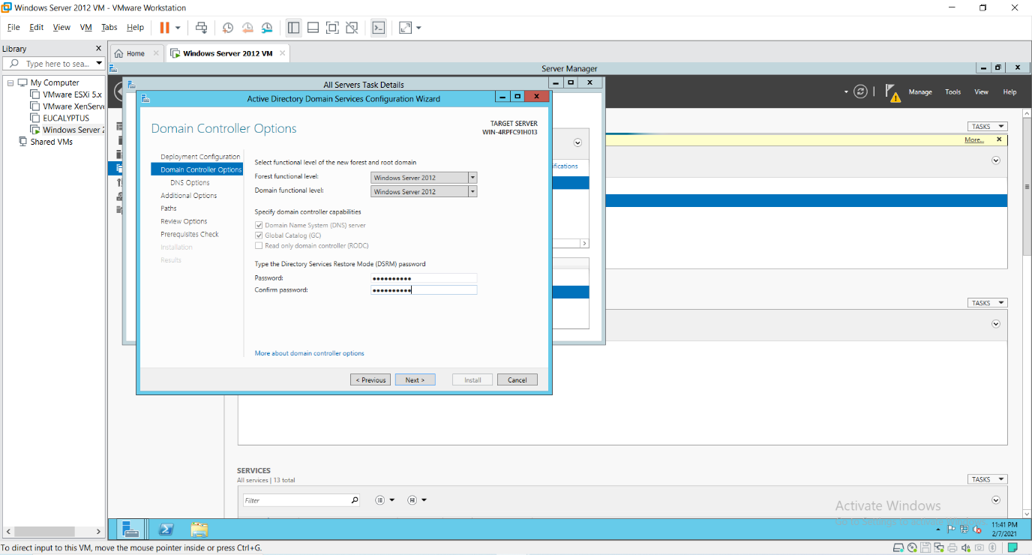

Click “Next”.

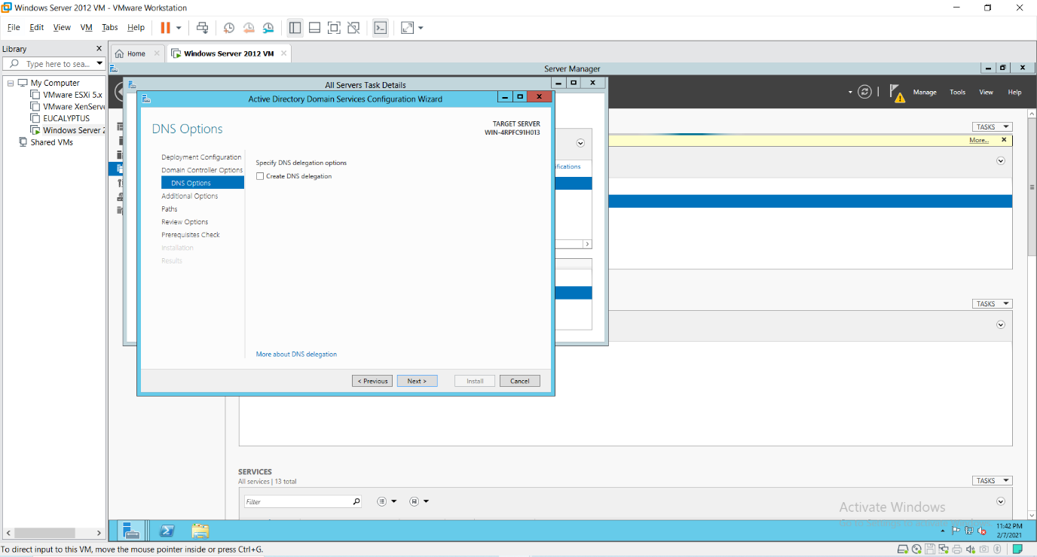

The NetBIOS Domain Name appears here automatically when you click on the Textbox. Click “Next”.

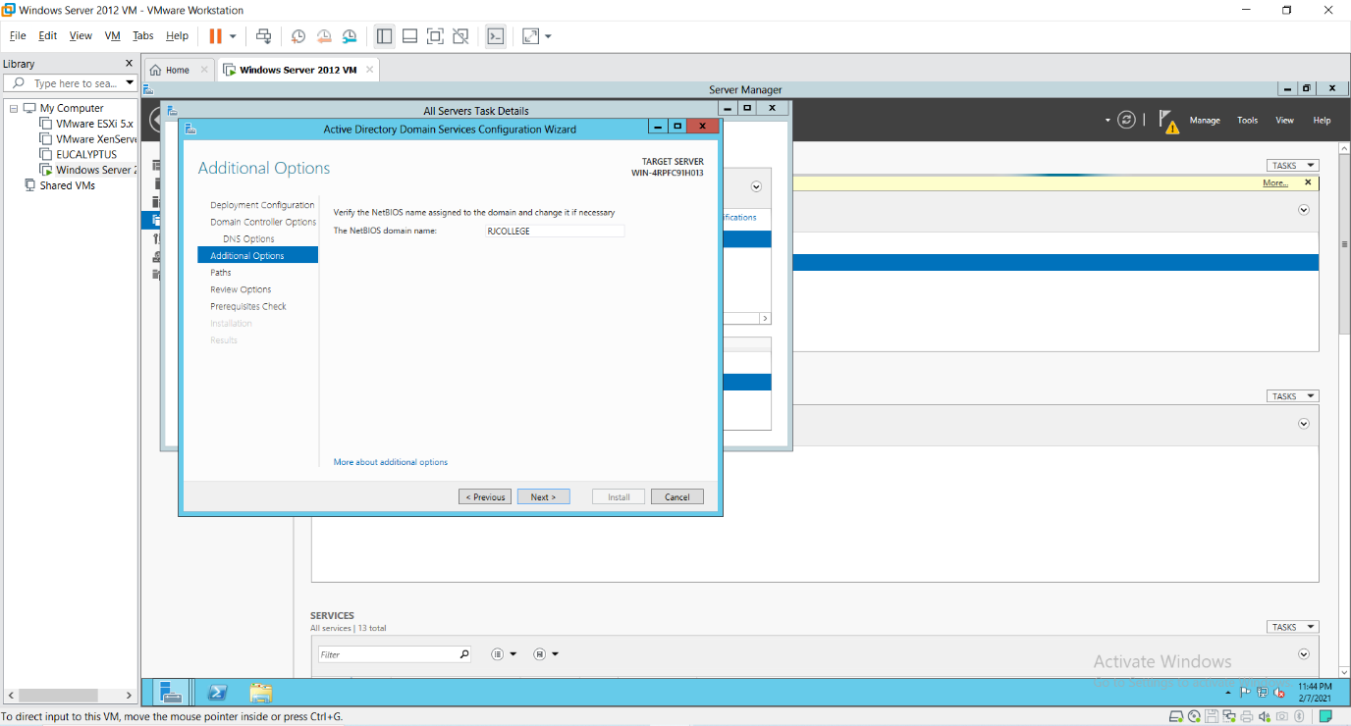

Click “Next”.

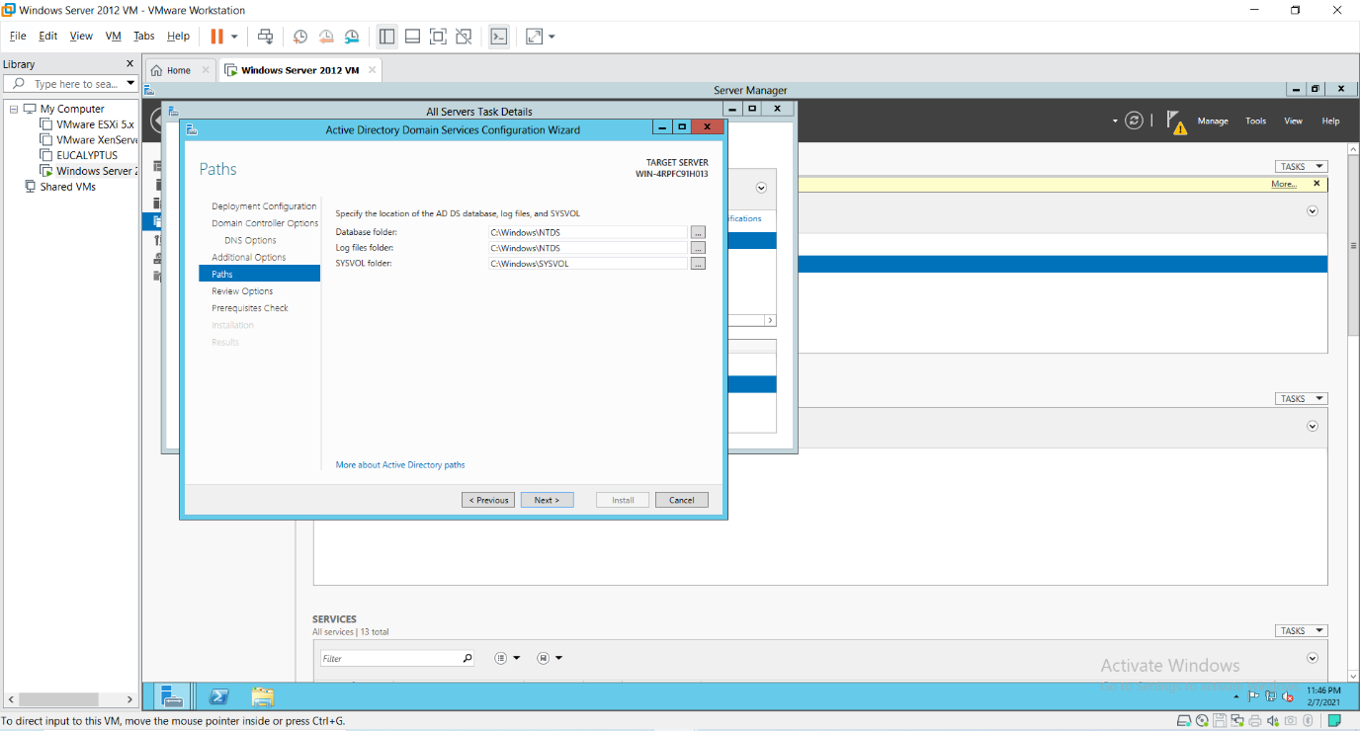

Under **“Review Options”** it shows us whatever we have selected for the Domain Controller.

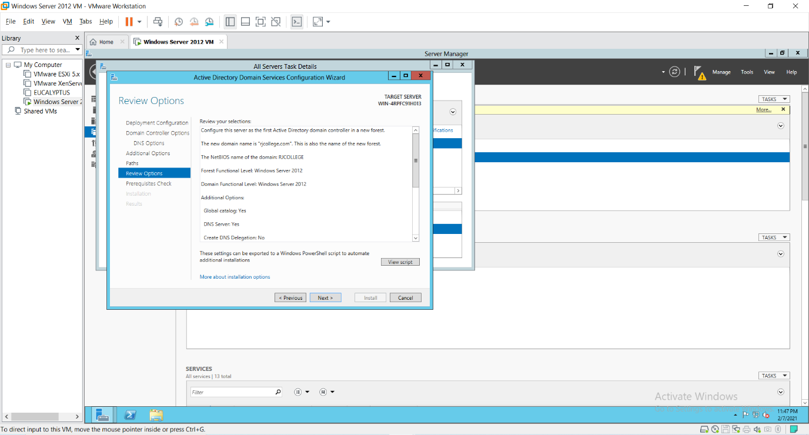

It checks for all the Prerequisites required to create a Domain Controller under “Prerequisites Check”. Click on “Install” button.

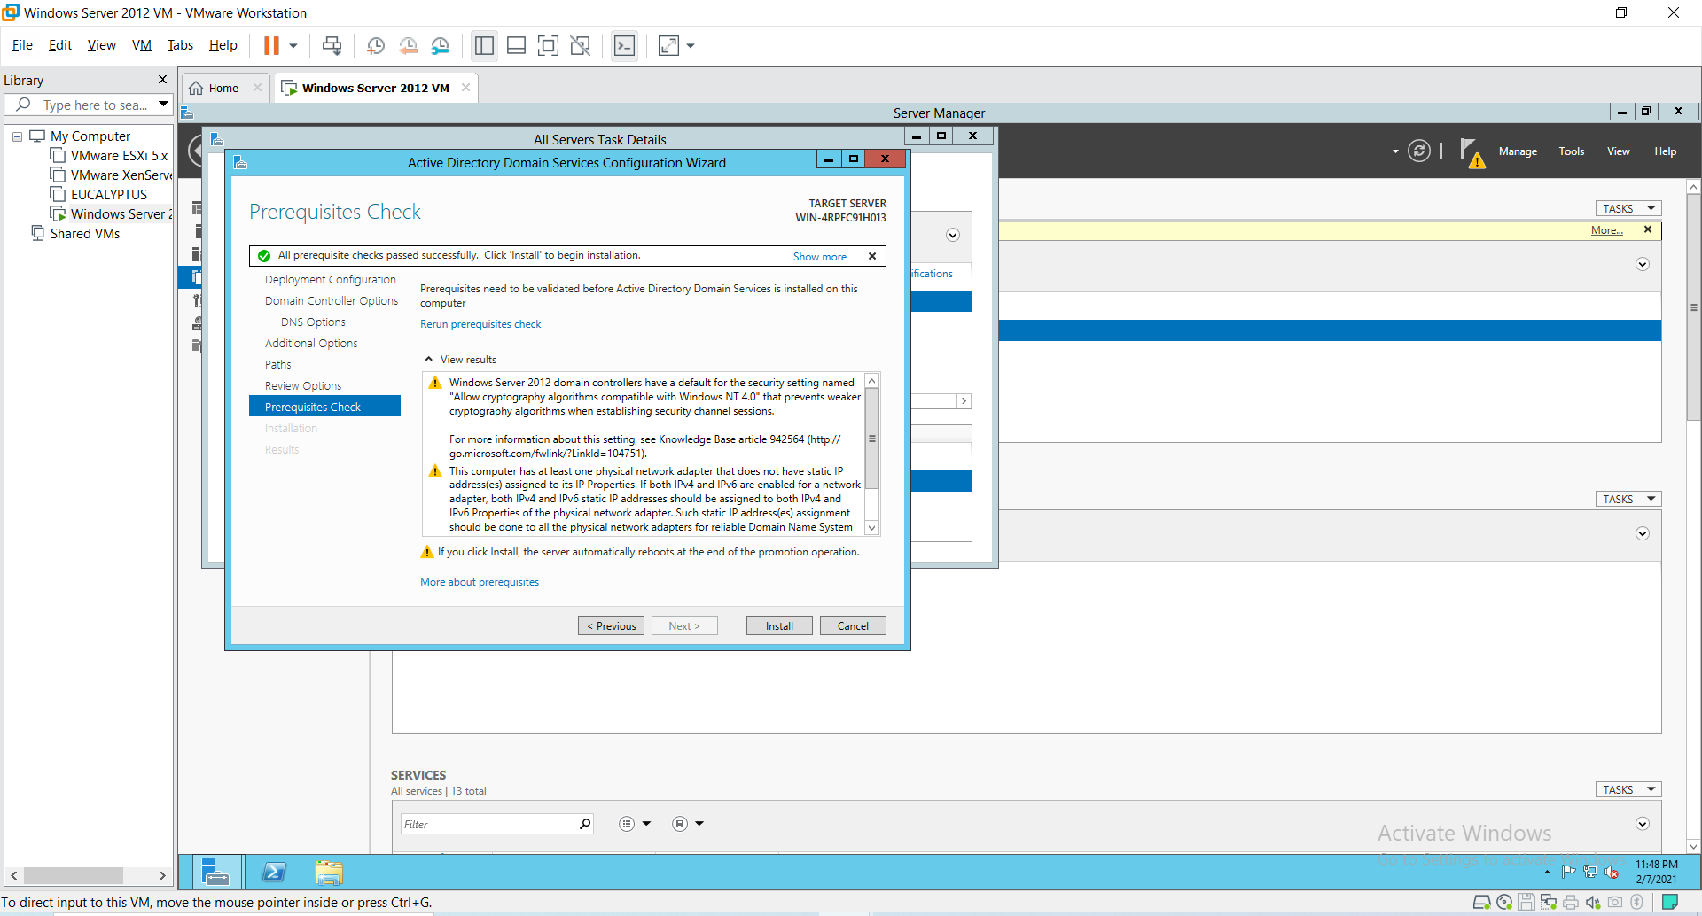

After installation PC will get restarted.

17) CREATING FAILOVER CLUSTER: Click on the **“Failover Cluster Manger”** under the tools menu to get the following screen.

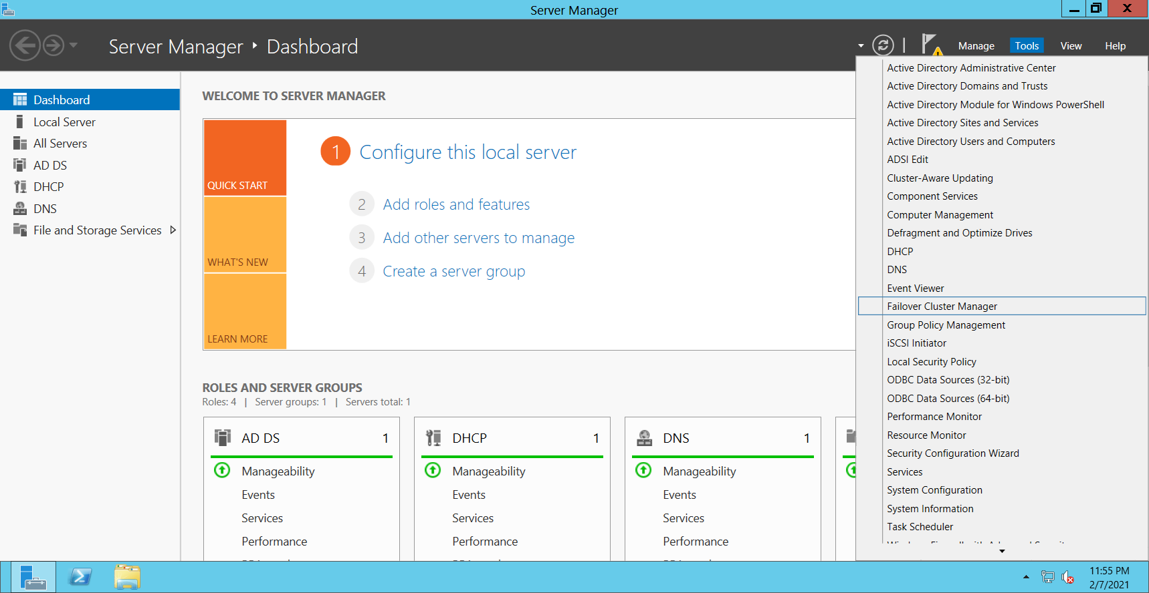

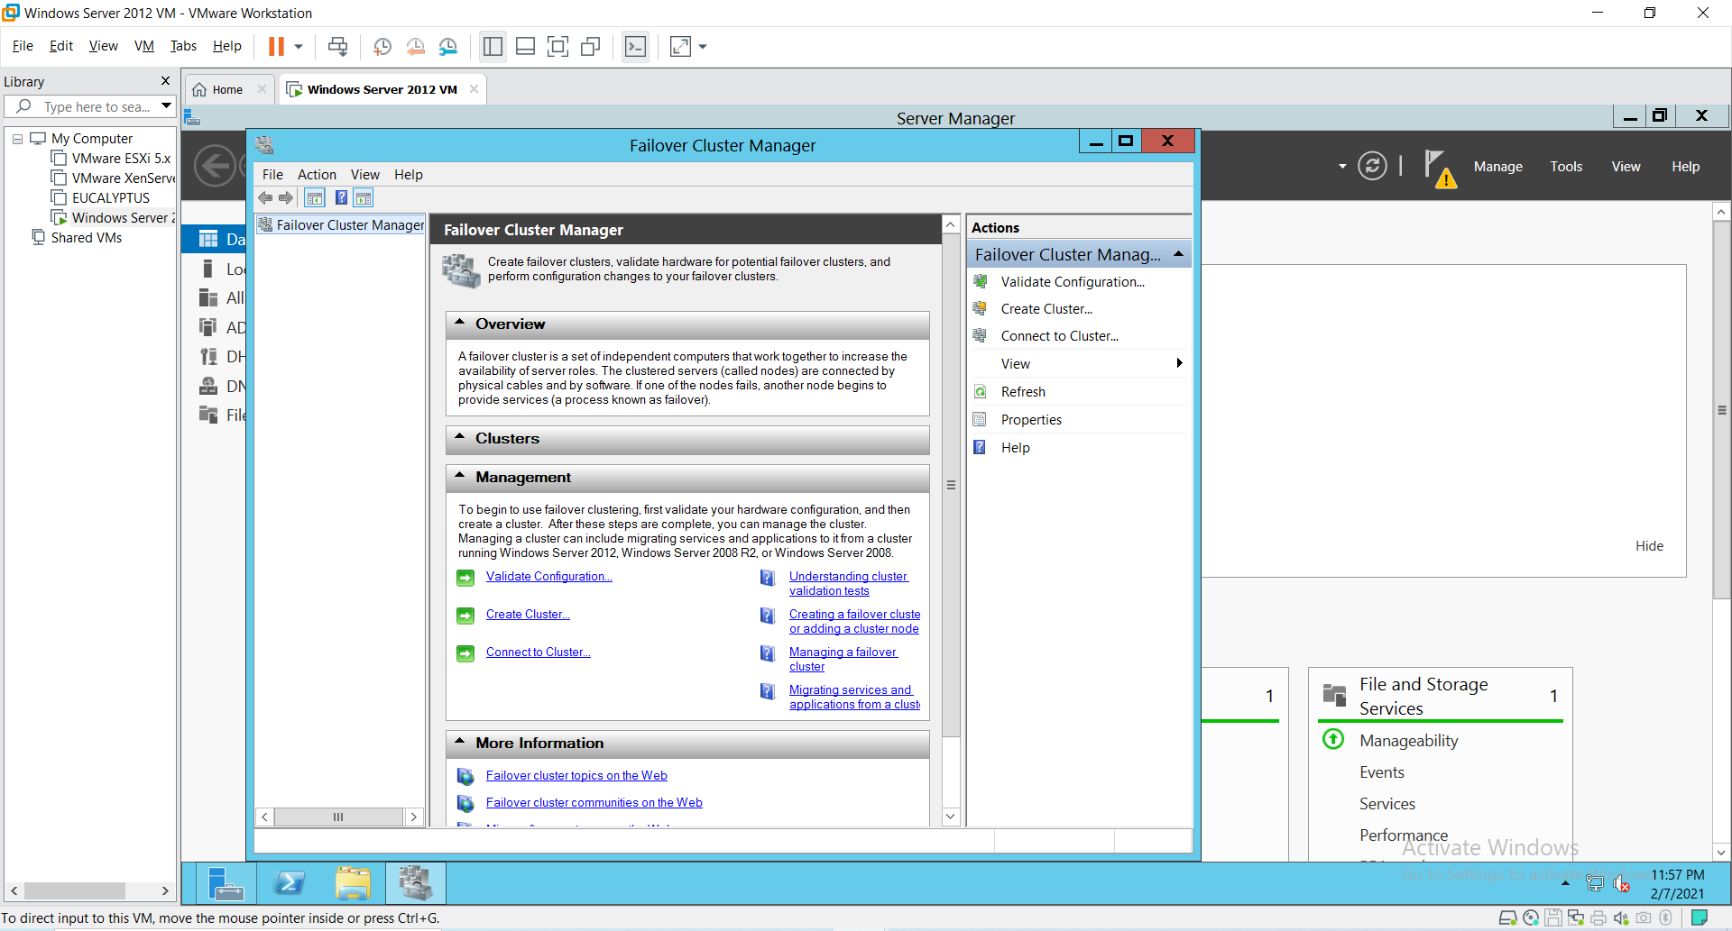

18)Click on **“Validation Configuration”** to open the **“Validate a Configuration Wizard”** by clicking on the **“Validate Configuration”** under the Management section at the bottom or right side of the screen. The nodes to be added must be validated prior to add in the cluster. Click “Next”.

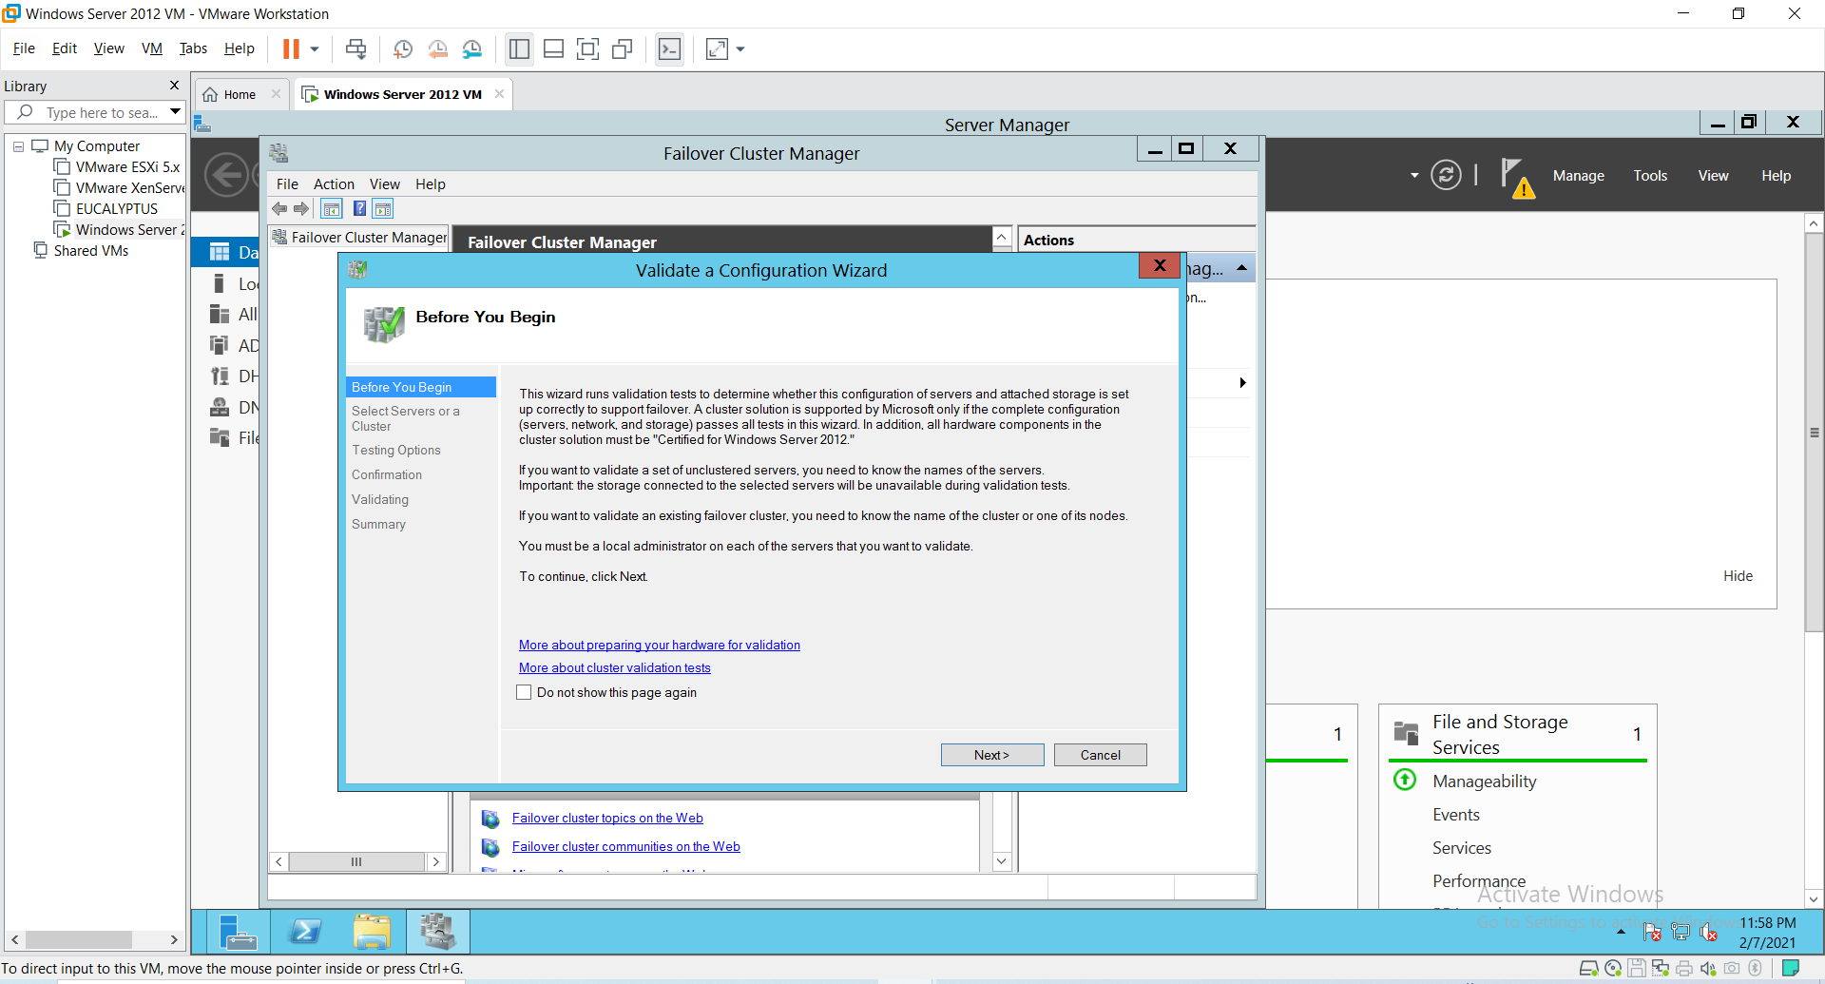

Click on **Browse** button and then **Advanced** for finding the domain node. As shown in below screens.

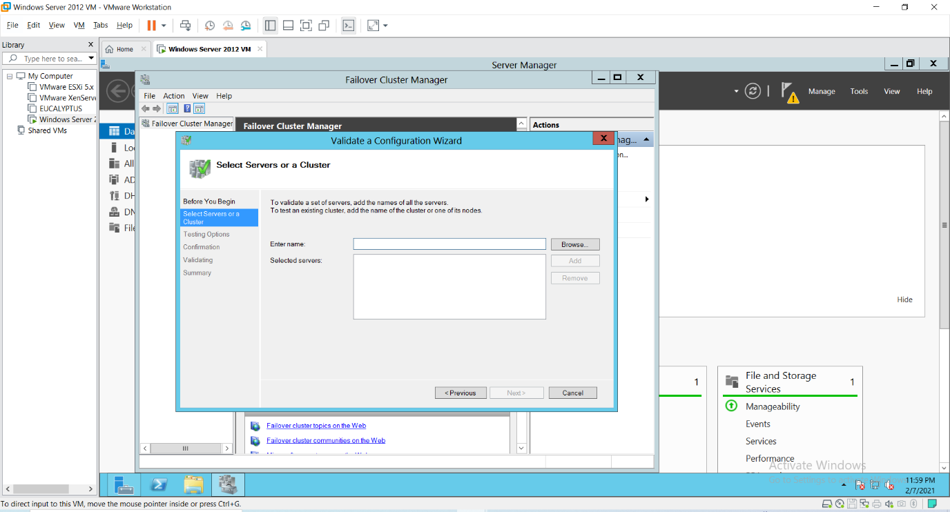

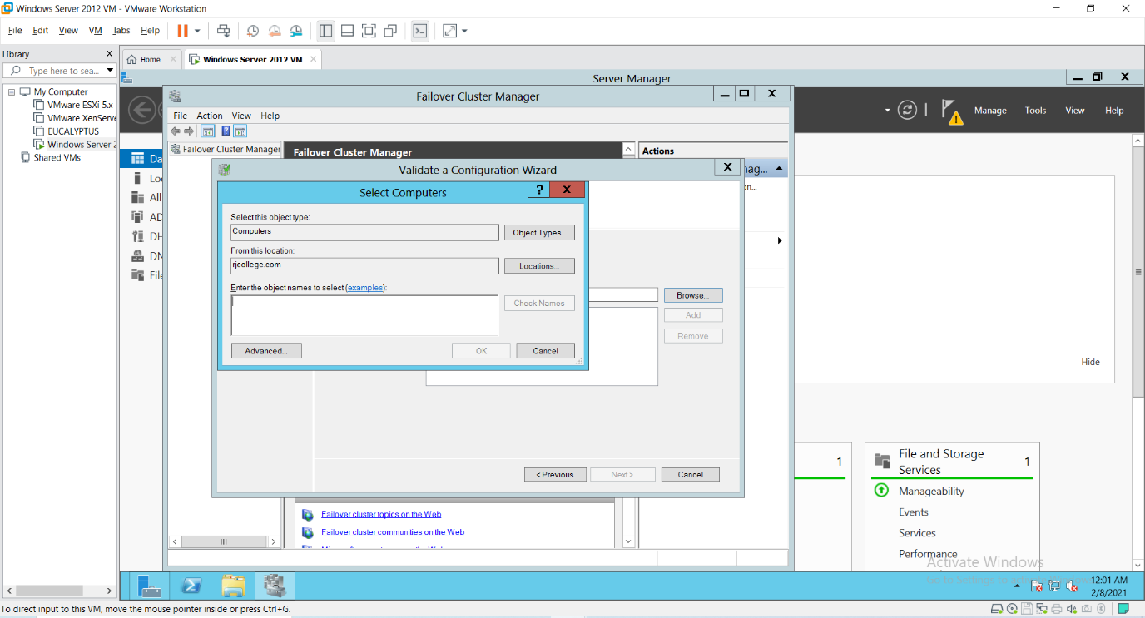

After clicking on **“Advanced”** button, click on **“Find Now”** button.

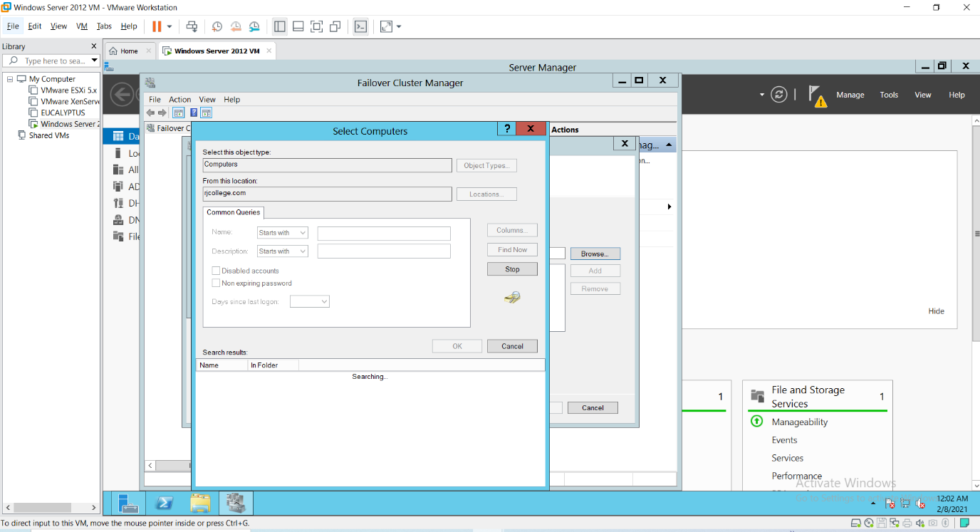

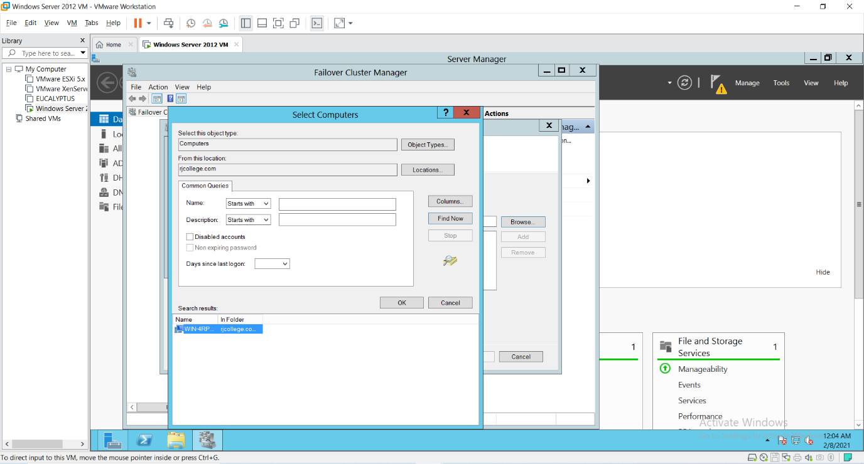

Click Ok.

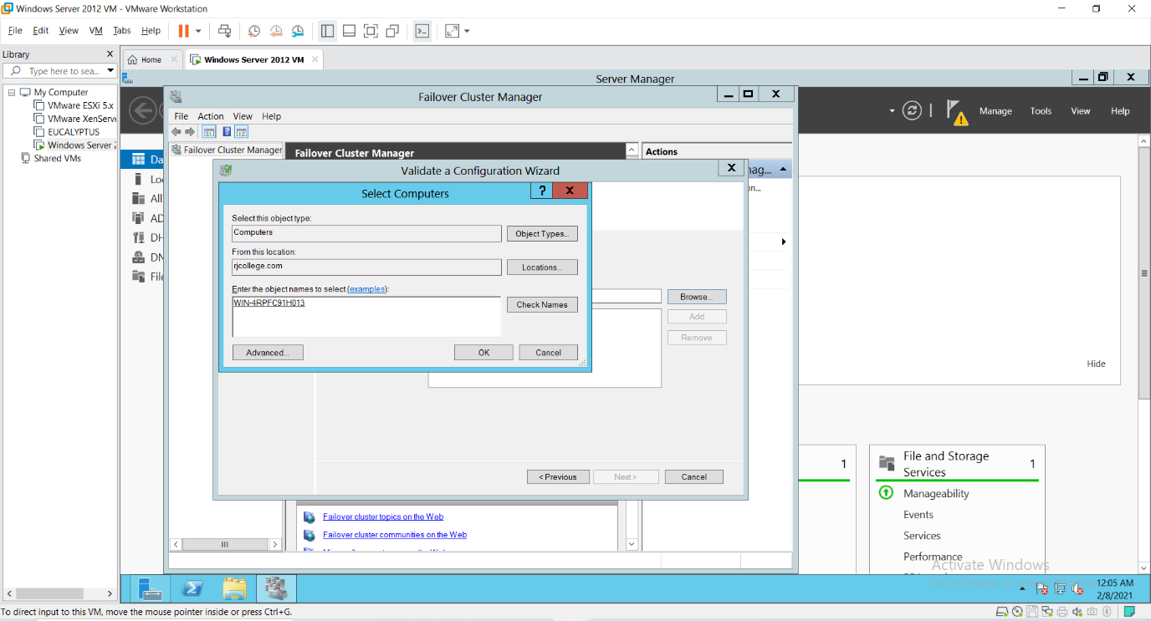

Click Ok.

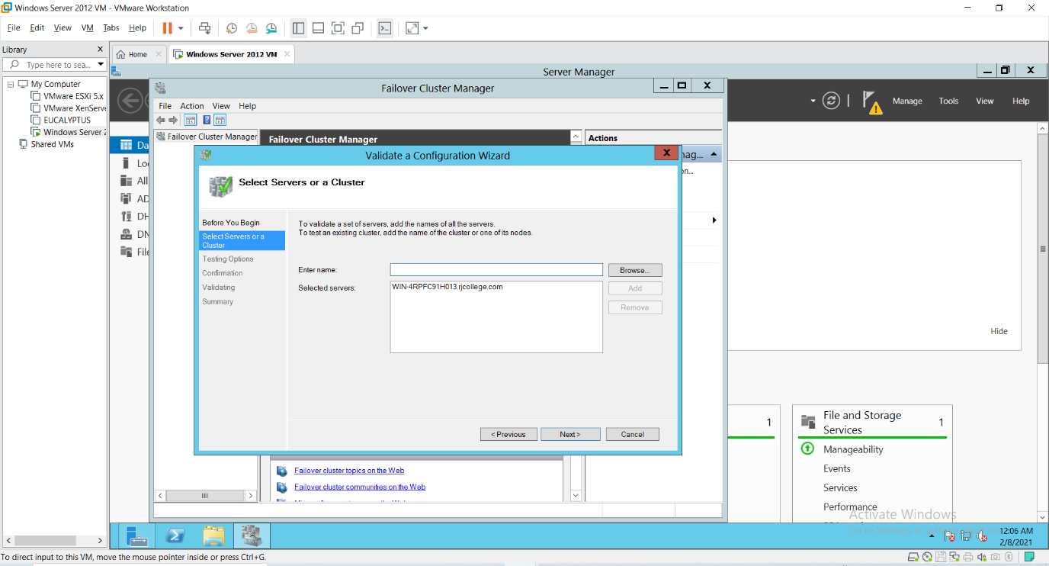

Click Next.

19)Click on **Run all tests** and Click Next.

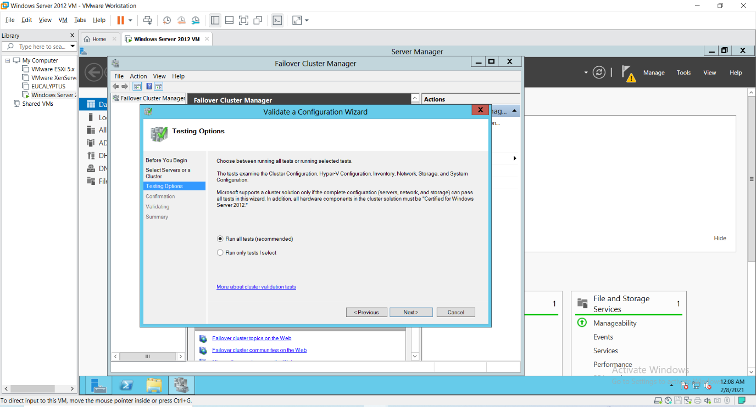

20) It will ask for the confirmation click “Next”. It will start all test validation.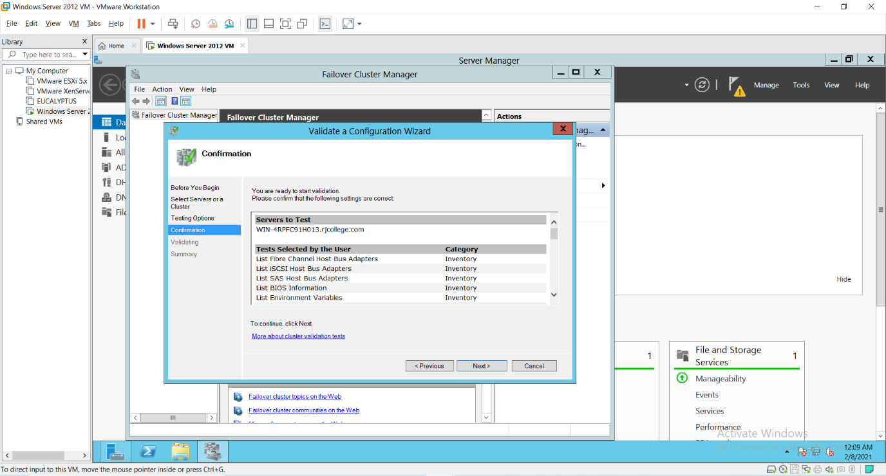

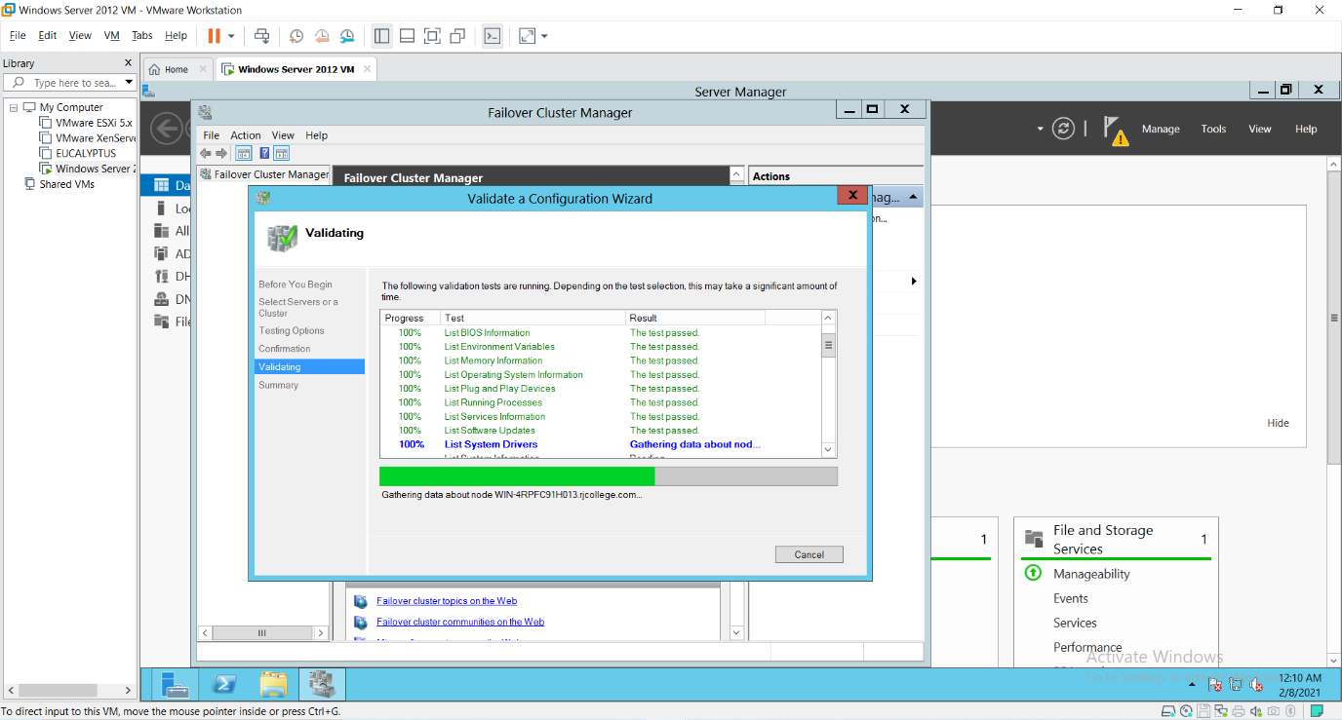

After completion it will display the summary report as shown below. If there are any errors can be seen here and you will not be allowed to create the cluster. As shown in the screen we can see that the **nodes are validated**. Click on finish.

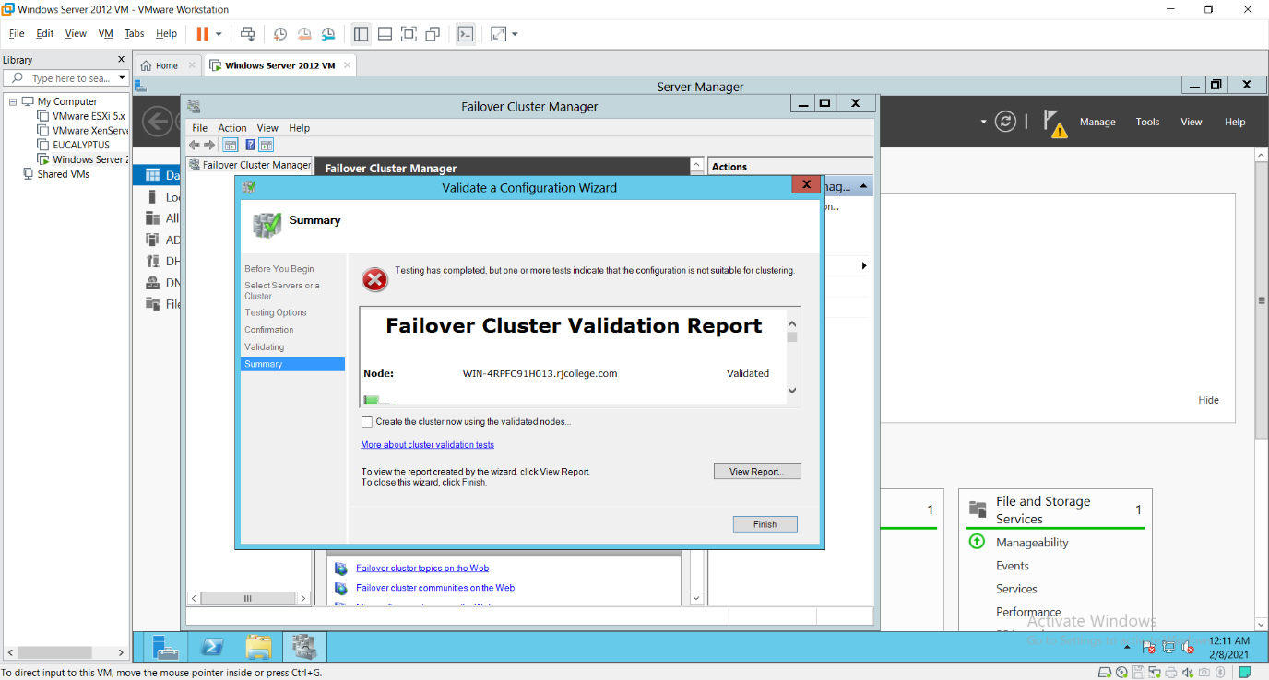

21) Now to create cluster click the **“Create Cluster”**.

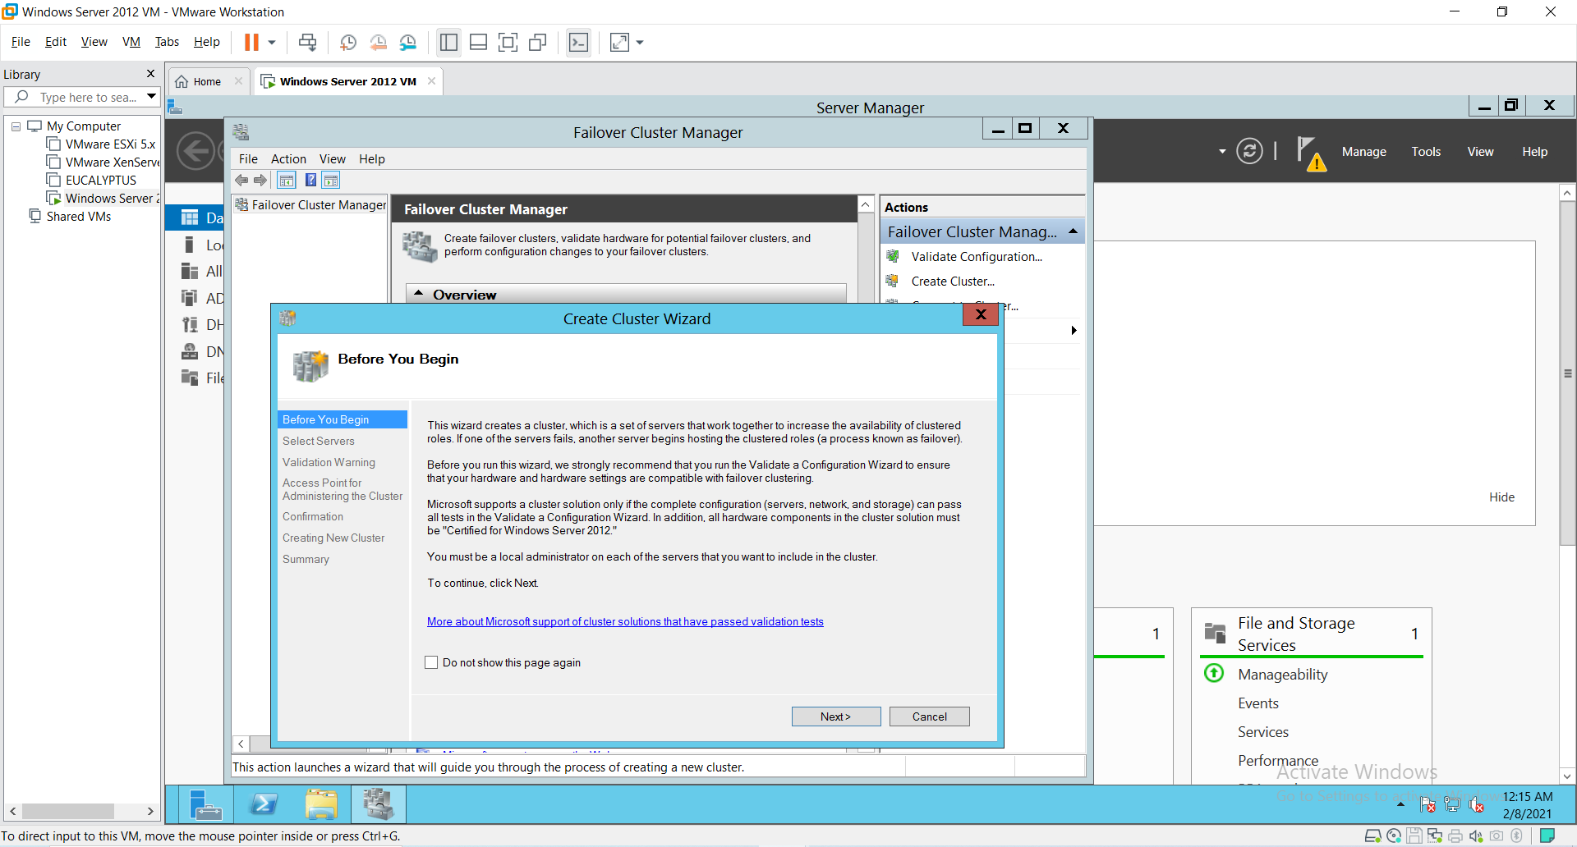

click Next.

22) Specify the Cluster name. Cluster name here should be the NetBIOS name of the Domain Controller, so here it is RJC_Node. Click next.

The **Selected Servers** will be the NetBIOS name of the Domain Controller i.e., RJC_Node which will be getting find when click on **Browse** button same as Step 18.

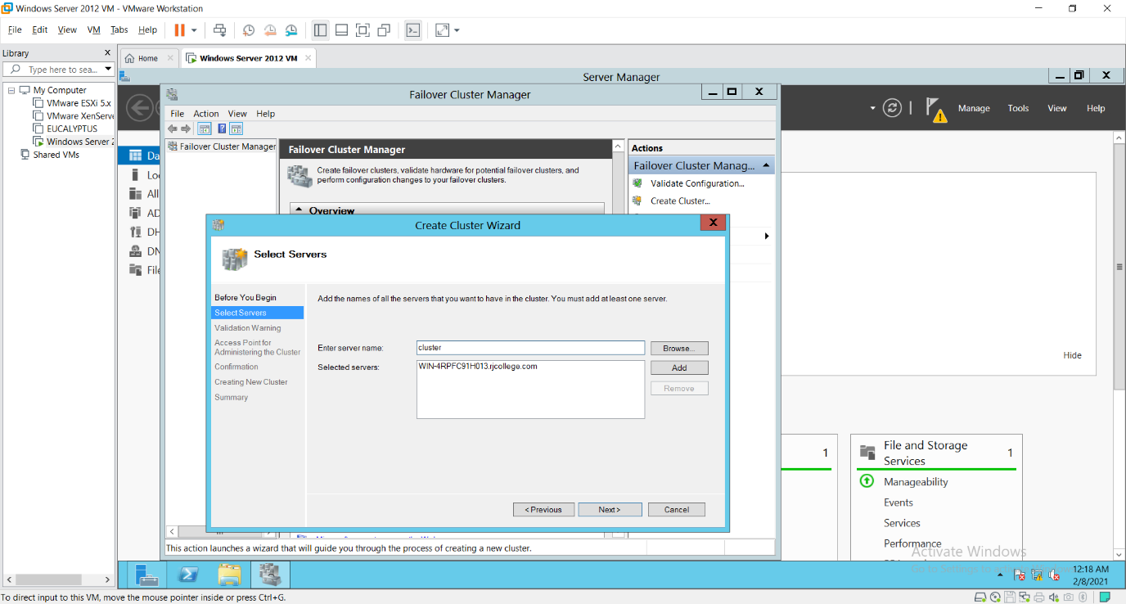

Click “Next”.

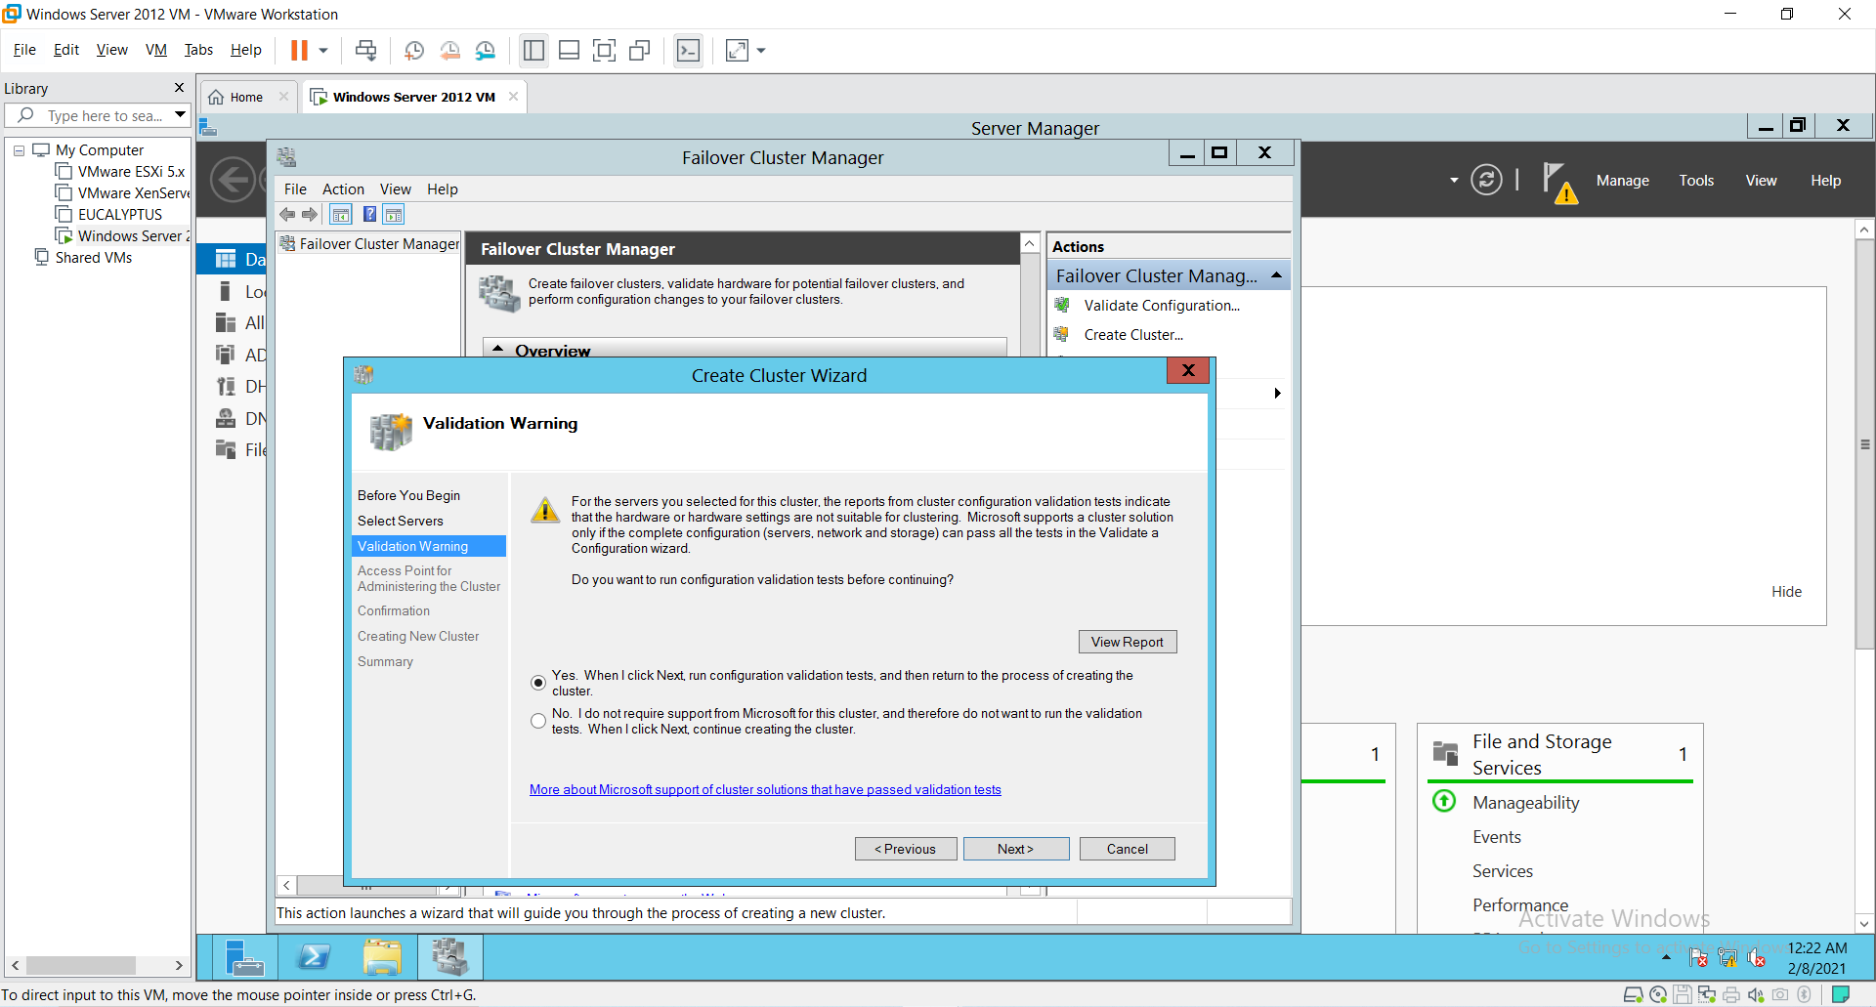

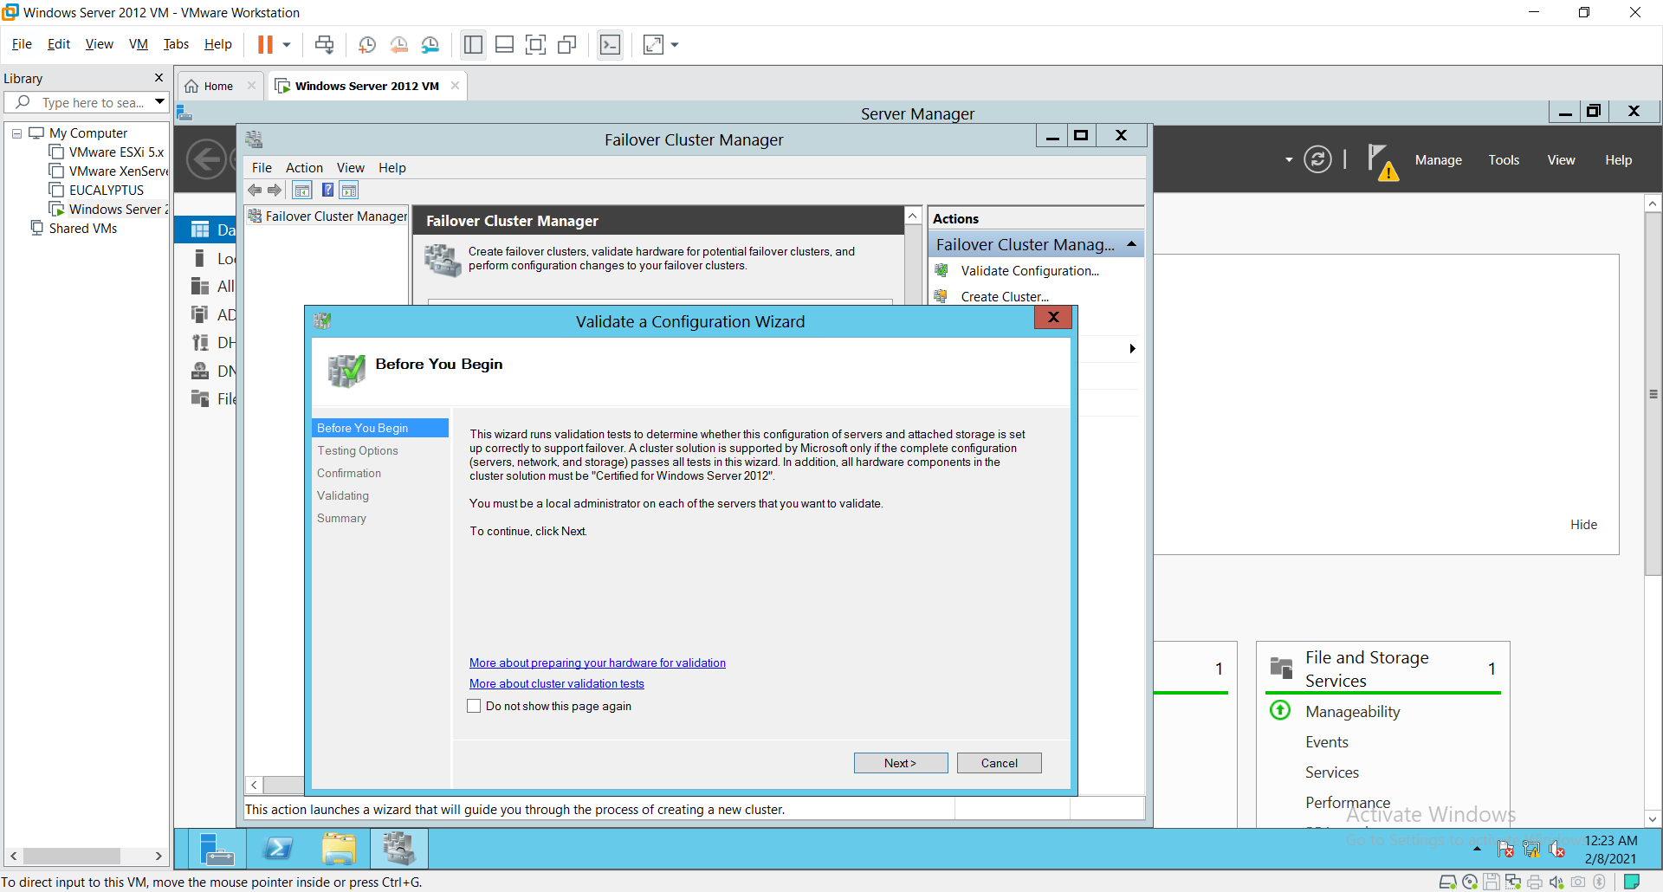

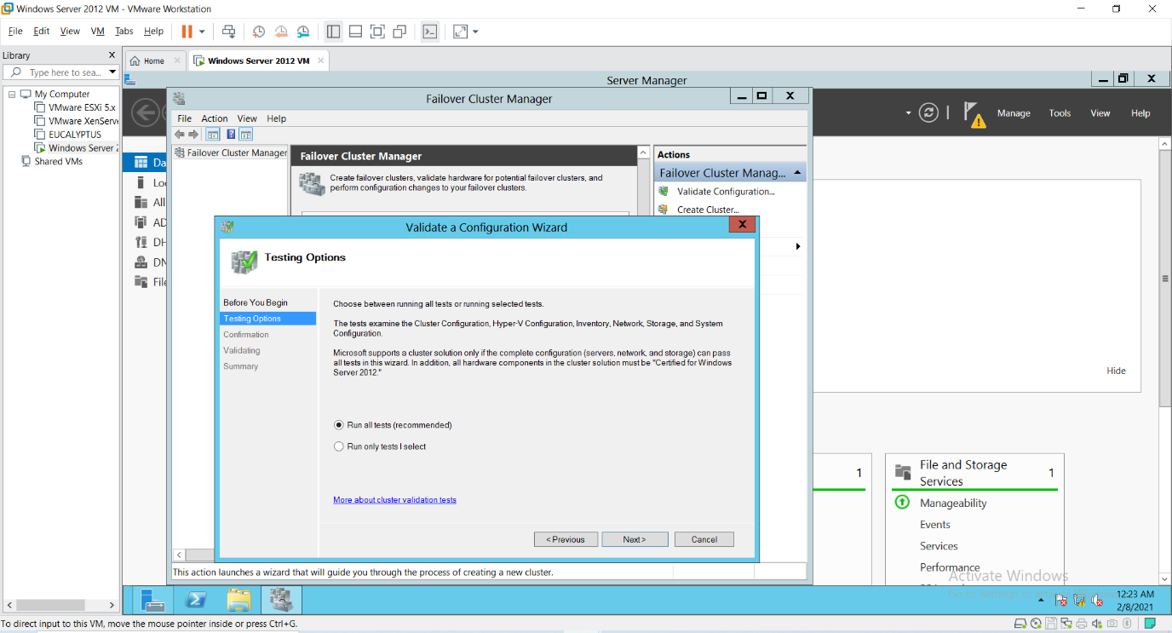

Click on Next. The cluster will get Validated.

Then click on **No radio button** when validation is done and you come back to the same screen and Click Next.

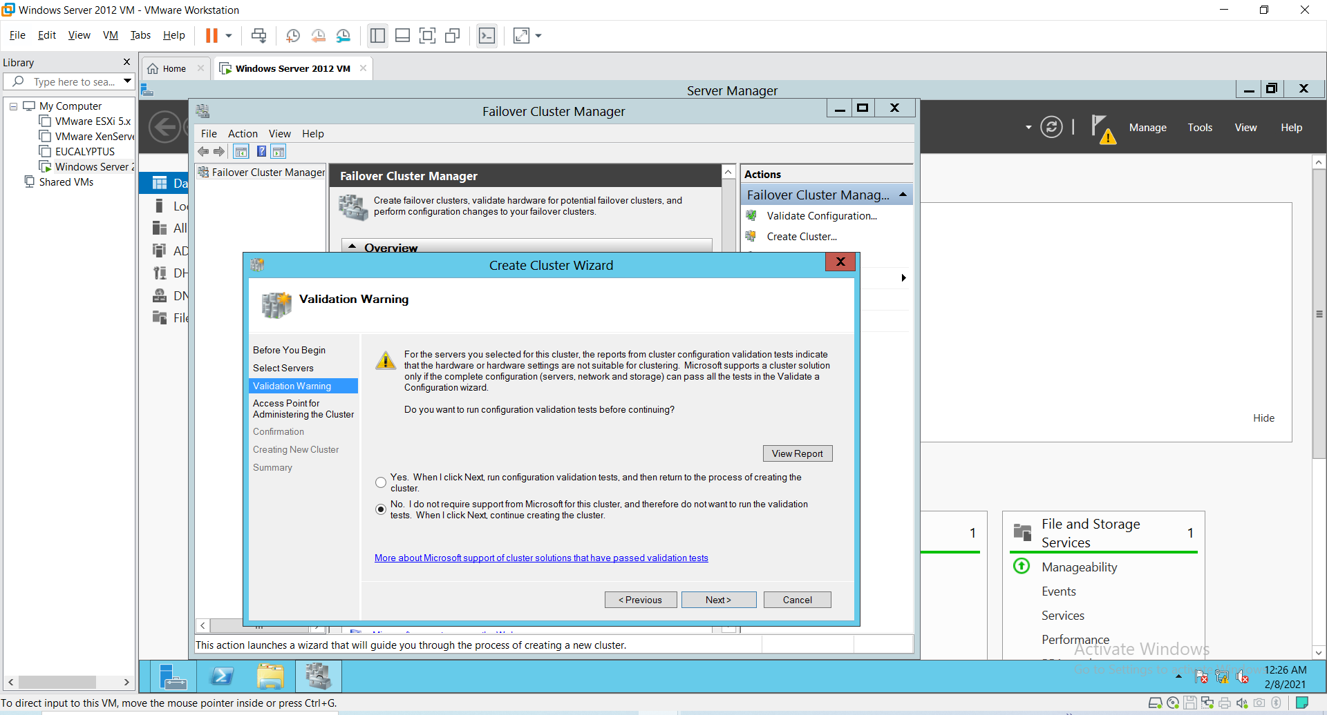

Give cluster name.

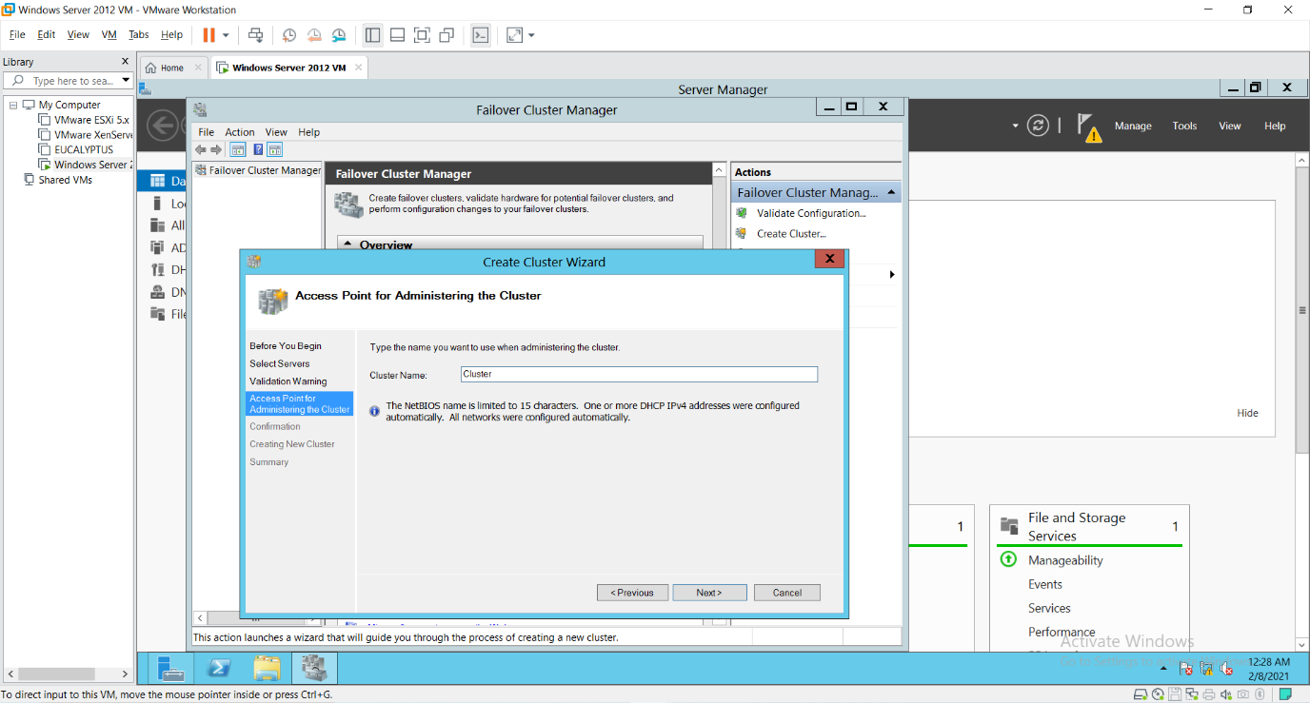

It will ask for the confirmation of cluster Creation. Click “Next”.

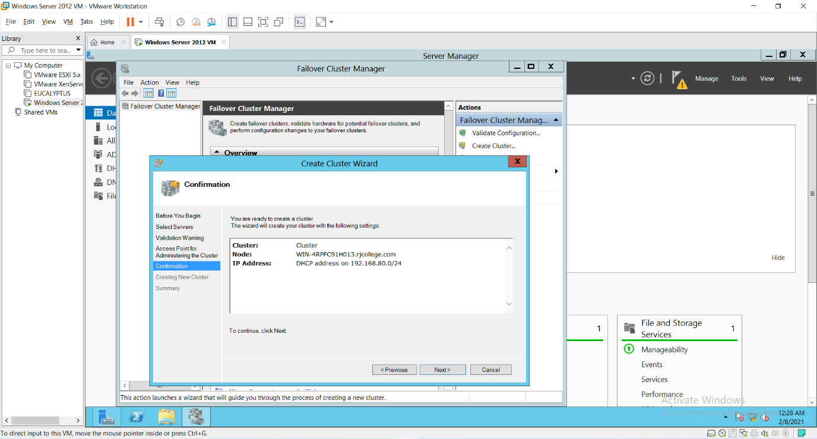

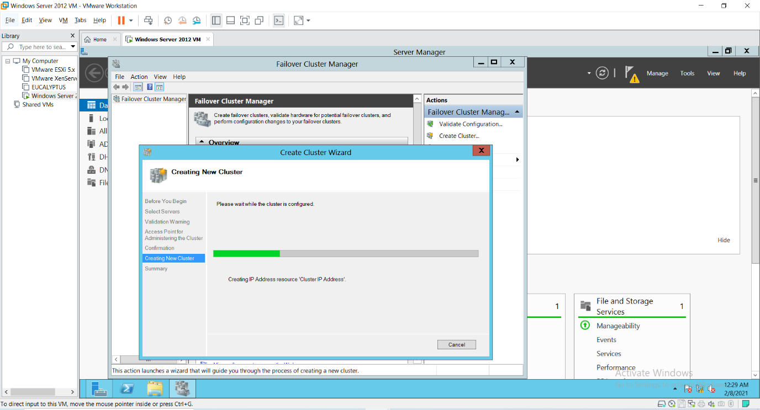

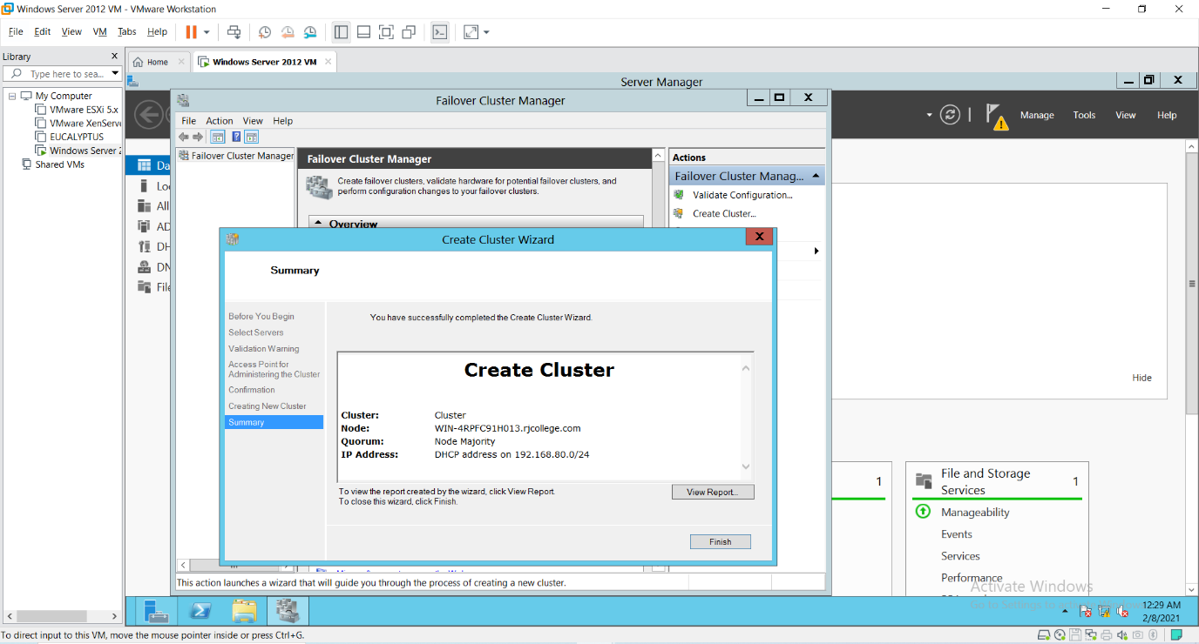

If the Cluster creation is successful you should see the following screen that shows a message **“You have successfully completed the Create Cluster Wizard”** and click **“Finish”**.

After cluster gets created you can see the cluster on the left side as shown in the screen below.

